

*The Seventeenth Sunday after Pentecost*

*October 5, 2025, 10:30am*

*Sung Eucharist*

***Website:*** *www.sthildasanglicanchurch.com*

***Church Email:*** *info@sthildasanglicanchurch.com*

***Facebook:*** *St. Hilda’s Fairbank Anglican Church*

*Incumbent: Fr. Kenute Francis (437-488-9657)*

[*kenute@sthildasanglicanchurch.com*](mailto:kenute@sthildasanglicanchurch.com)

*Honorary Assistant: Canon Leonard Abbah, OHC*

*Organist: William “Bill” Khan*

***Crucifer:*** *Kishmar Miller*

***Eucharistic Ministers:*** *Ianthe Alleyne,**Errol Parris & William Greenidge*

***Readers:***

***1st Reading:*** *Marcia Lee*

***2nd Reading:*** *Tessa Phillip*

***Gospel:*** *Ianthe Alleyne*

***Intercession:*** *Sonia Wickham*

*Tech Team: Brenda Ferary & Richard Morris*

*Ushers Team 2: Oscar Lewis Percy Lorde*

*Isla Barnes Thora Layne*

*John Goddard Brenda Ferary*

*Merlene Eastmond*

*MISSION STATEMENT*

*The purpose of St. Hilda’s Church is to be Christ-centered in our life and worship,*

*to serve lovingly those within our family and others within our reach*

*that the spirit of God might empower us for worship. service, education, stewardship, evangelism and pastoral care.*

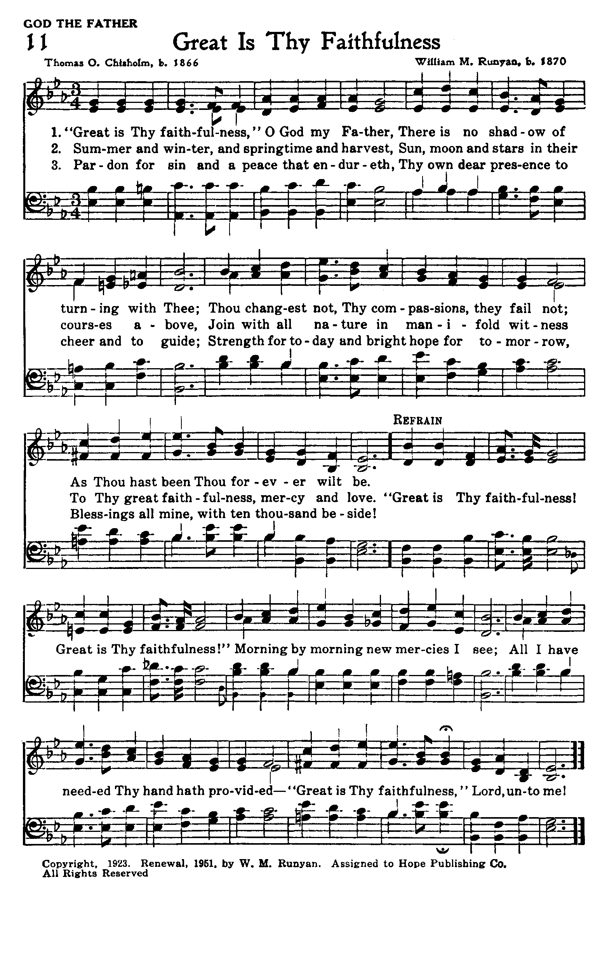

*The Order of Service*

*ORGAN PRELUDE: Great is Thy Faithfulness*

*FATHFULNESS*

**OPENING PRAYER**

Faithful God, we come before you with songs and with silence,

with joy and with longing. As we gather for worship, fill us with your Spirit,

renew us with your grace, and make us ready to follow Jesus,

in whose name we pray.

**Amen.**

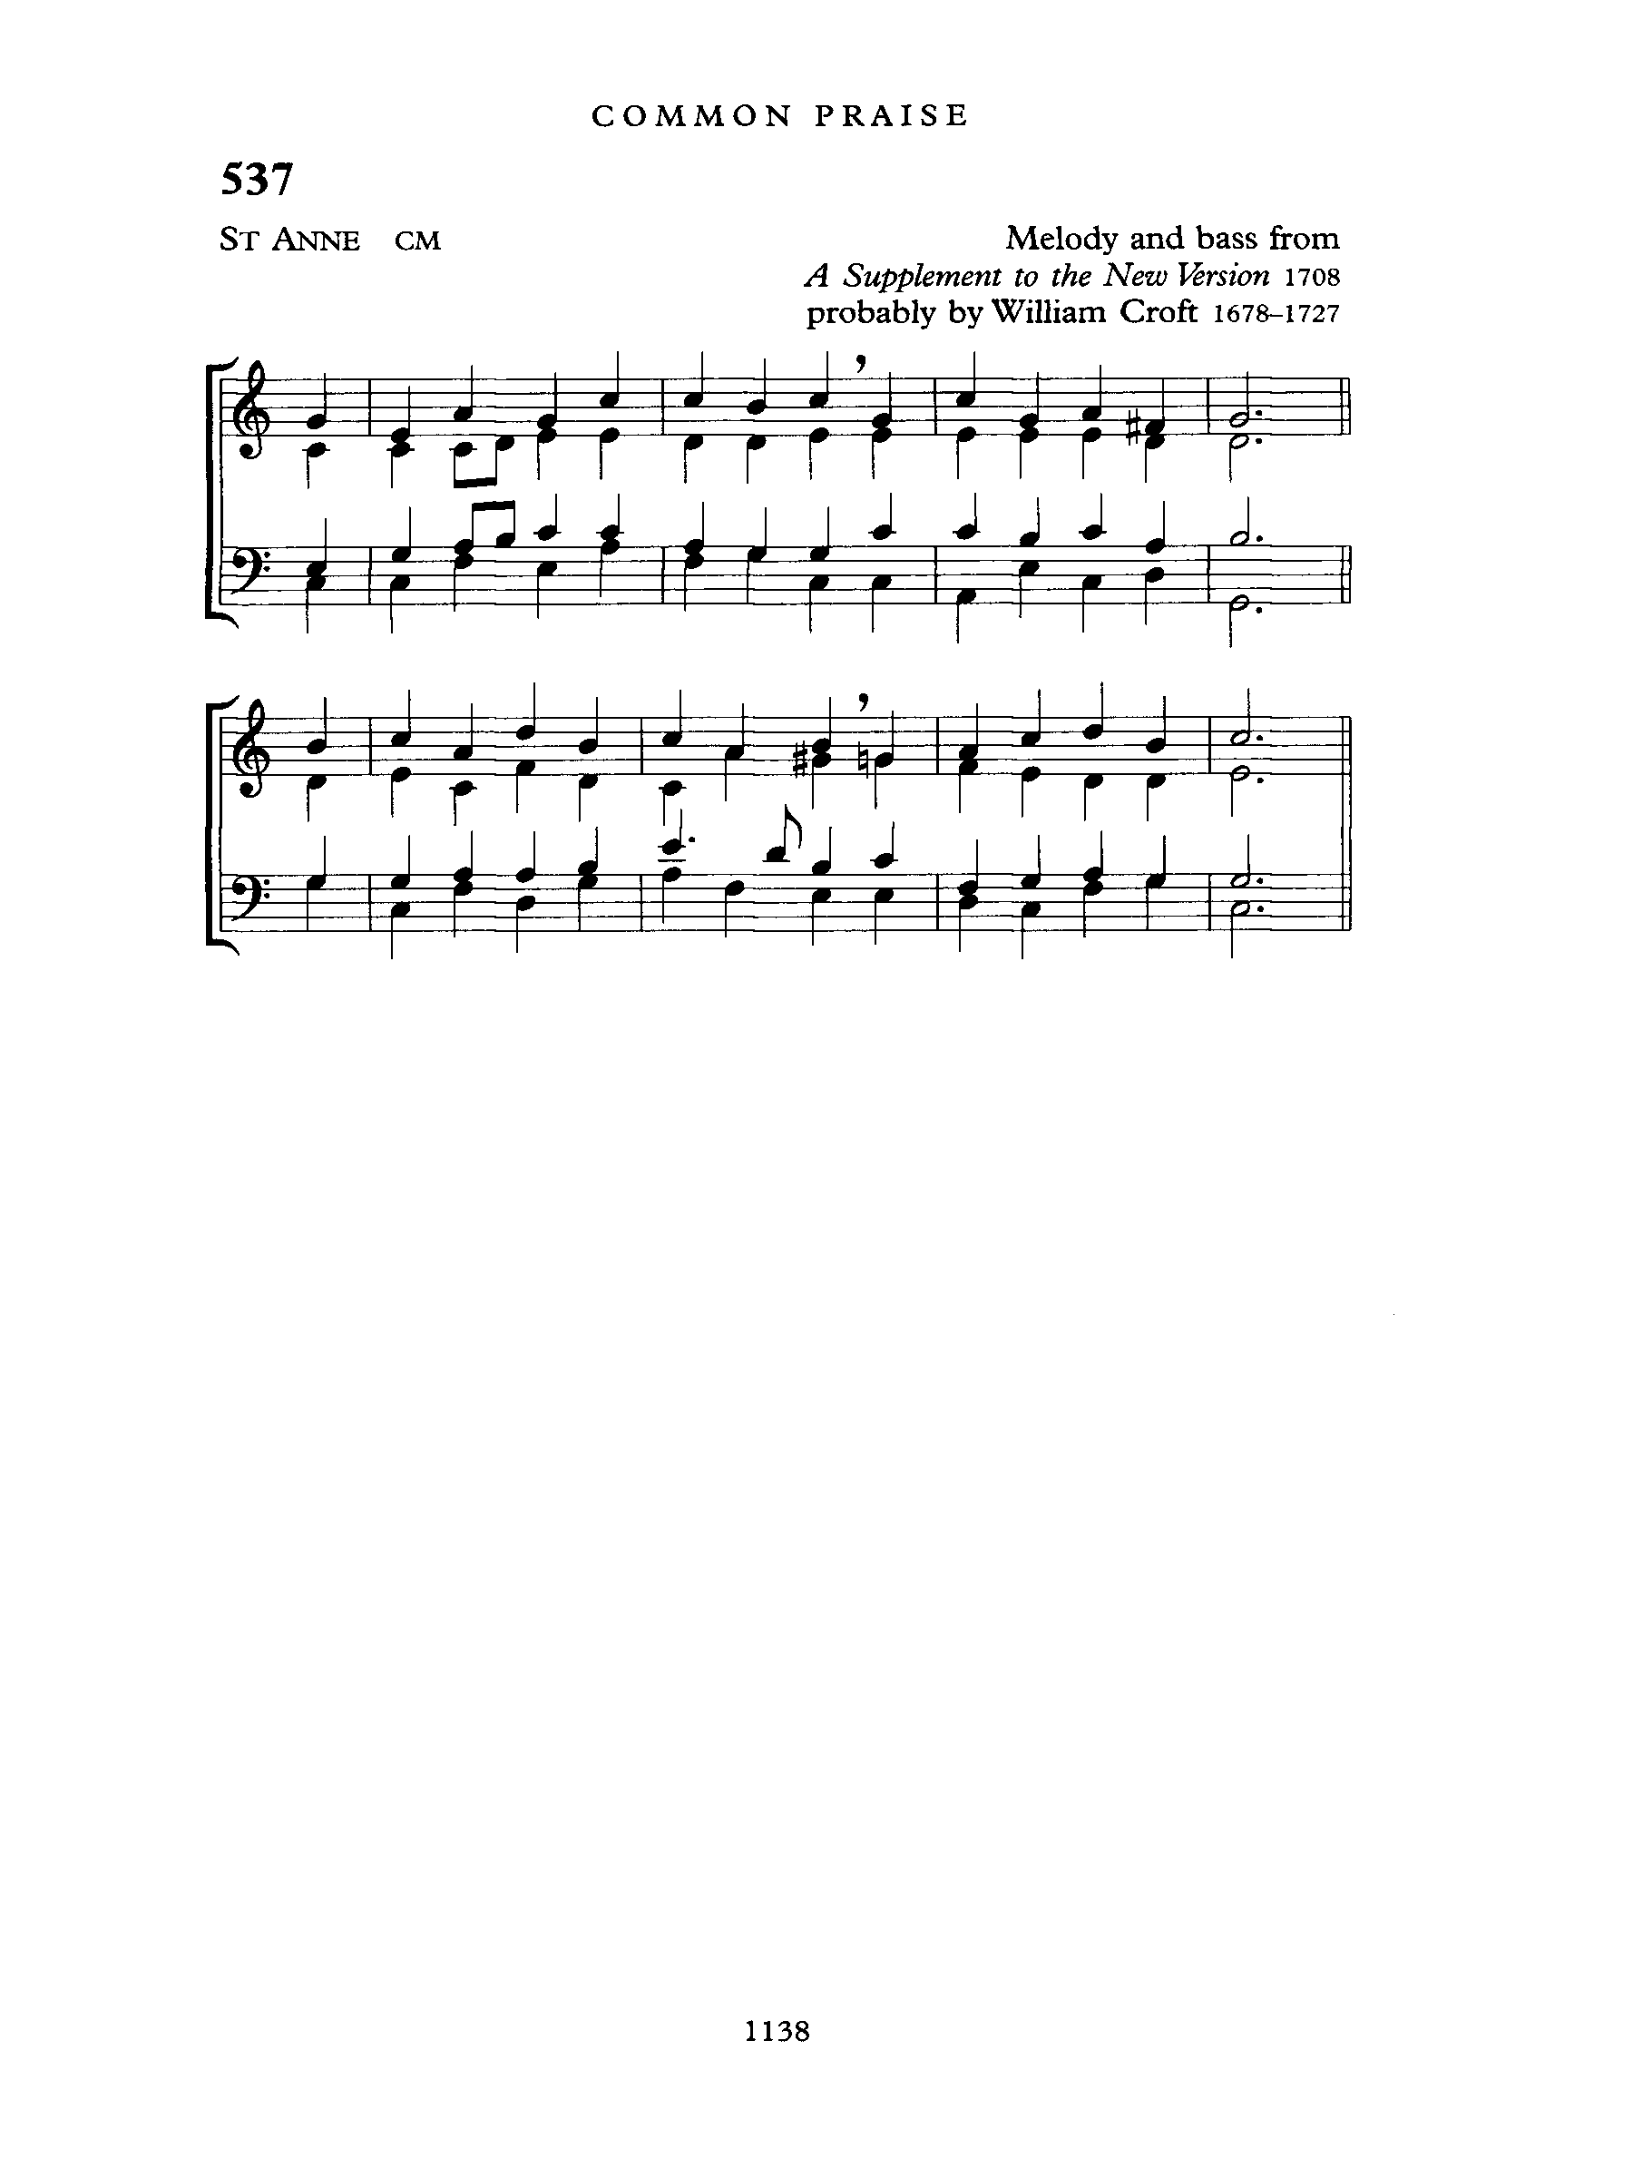

**PROCESSIONAL: O God, Our Help in Ages Past  
Text:** Isaac Watts**; Tune:**  *ST. ANNE*

O God, our help in ages past,  
Our hope for years to come,  
Our shelter from the stormy blast,  
And our eternal home.

Under the shadow of Thy throne  
Thy saints have dwelt secure;  
Sufficient is Thine arm alone,  
And our defense is sure.

Before the hills in order stood,  
Or earth received her frame,  
From everlasting Thou art God,  
To endless years the same.

A thousand ages in Thy sight  
Are like an evening gone;  
Short as the watch that ends the night  
Before the rising sun.

Time, like an ever-rolling stream,  
Bears all its sons away;  
They fly, forgotten, as a dream  
Dies at the opening day.

O God, our help in ages past,  
Our hope for years to come,  
Be Thou our guard while troubles last,  
And our eternal home.

**WELCOME:** *Fr. Kenute*

**GREETINGS:**

The grace of our Lord Jesus Christ, the love of God

and the fellowship of the Holy spirit be with you all.

**And also with you.**

Even when we feel far from home, God remembers us.

**God’s love endures forever!**

When faith feels small, the Spirit makes it grow.

**God’s power is made perfect in weakness!**

So we come—lamenting, hoping, trusting, and serving.

**Let us worship the Lord our God!**

**THE COLLECT FOR PURITY**

Almighty God,

**to you all hearts are open, all desires known,**

**and from you no secrets are hidden.**

**Cleanse the thoughts of our hearts by the inspiration of your Holy Spirit,**

**that we may perfectly love you, and worthily magnify your holy name;**

**through Christ our Lord. Amen.**

**CHILDREN/YOUTH TIME:**

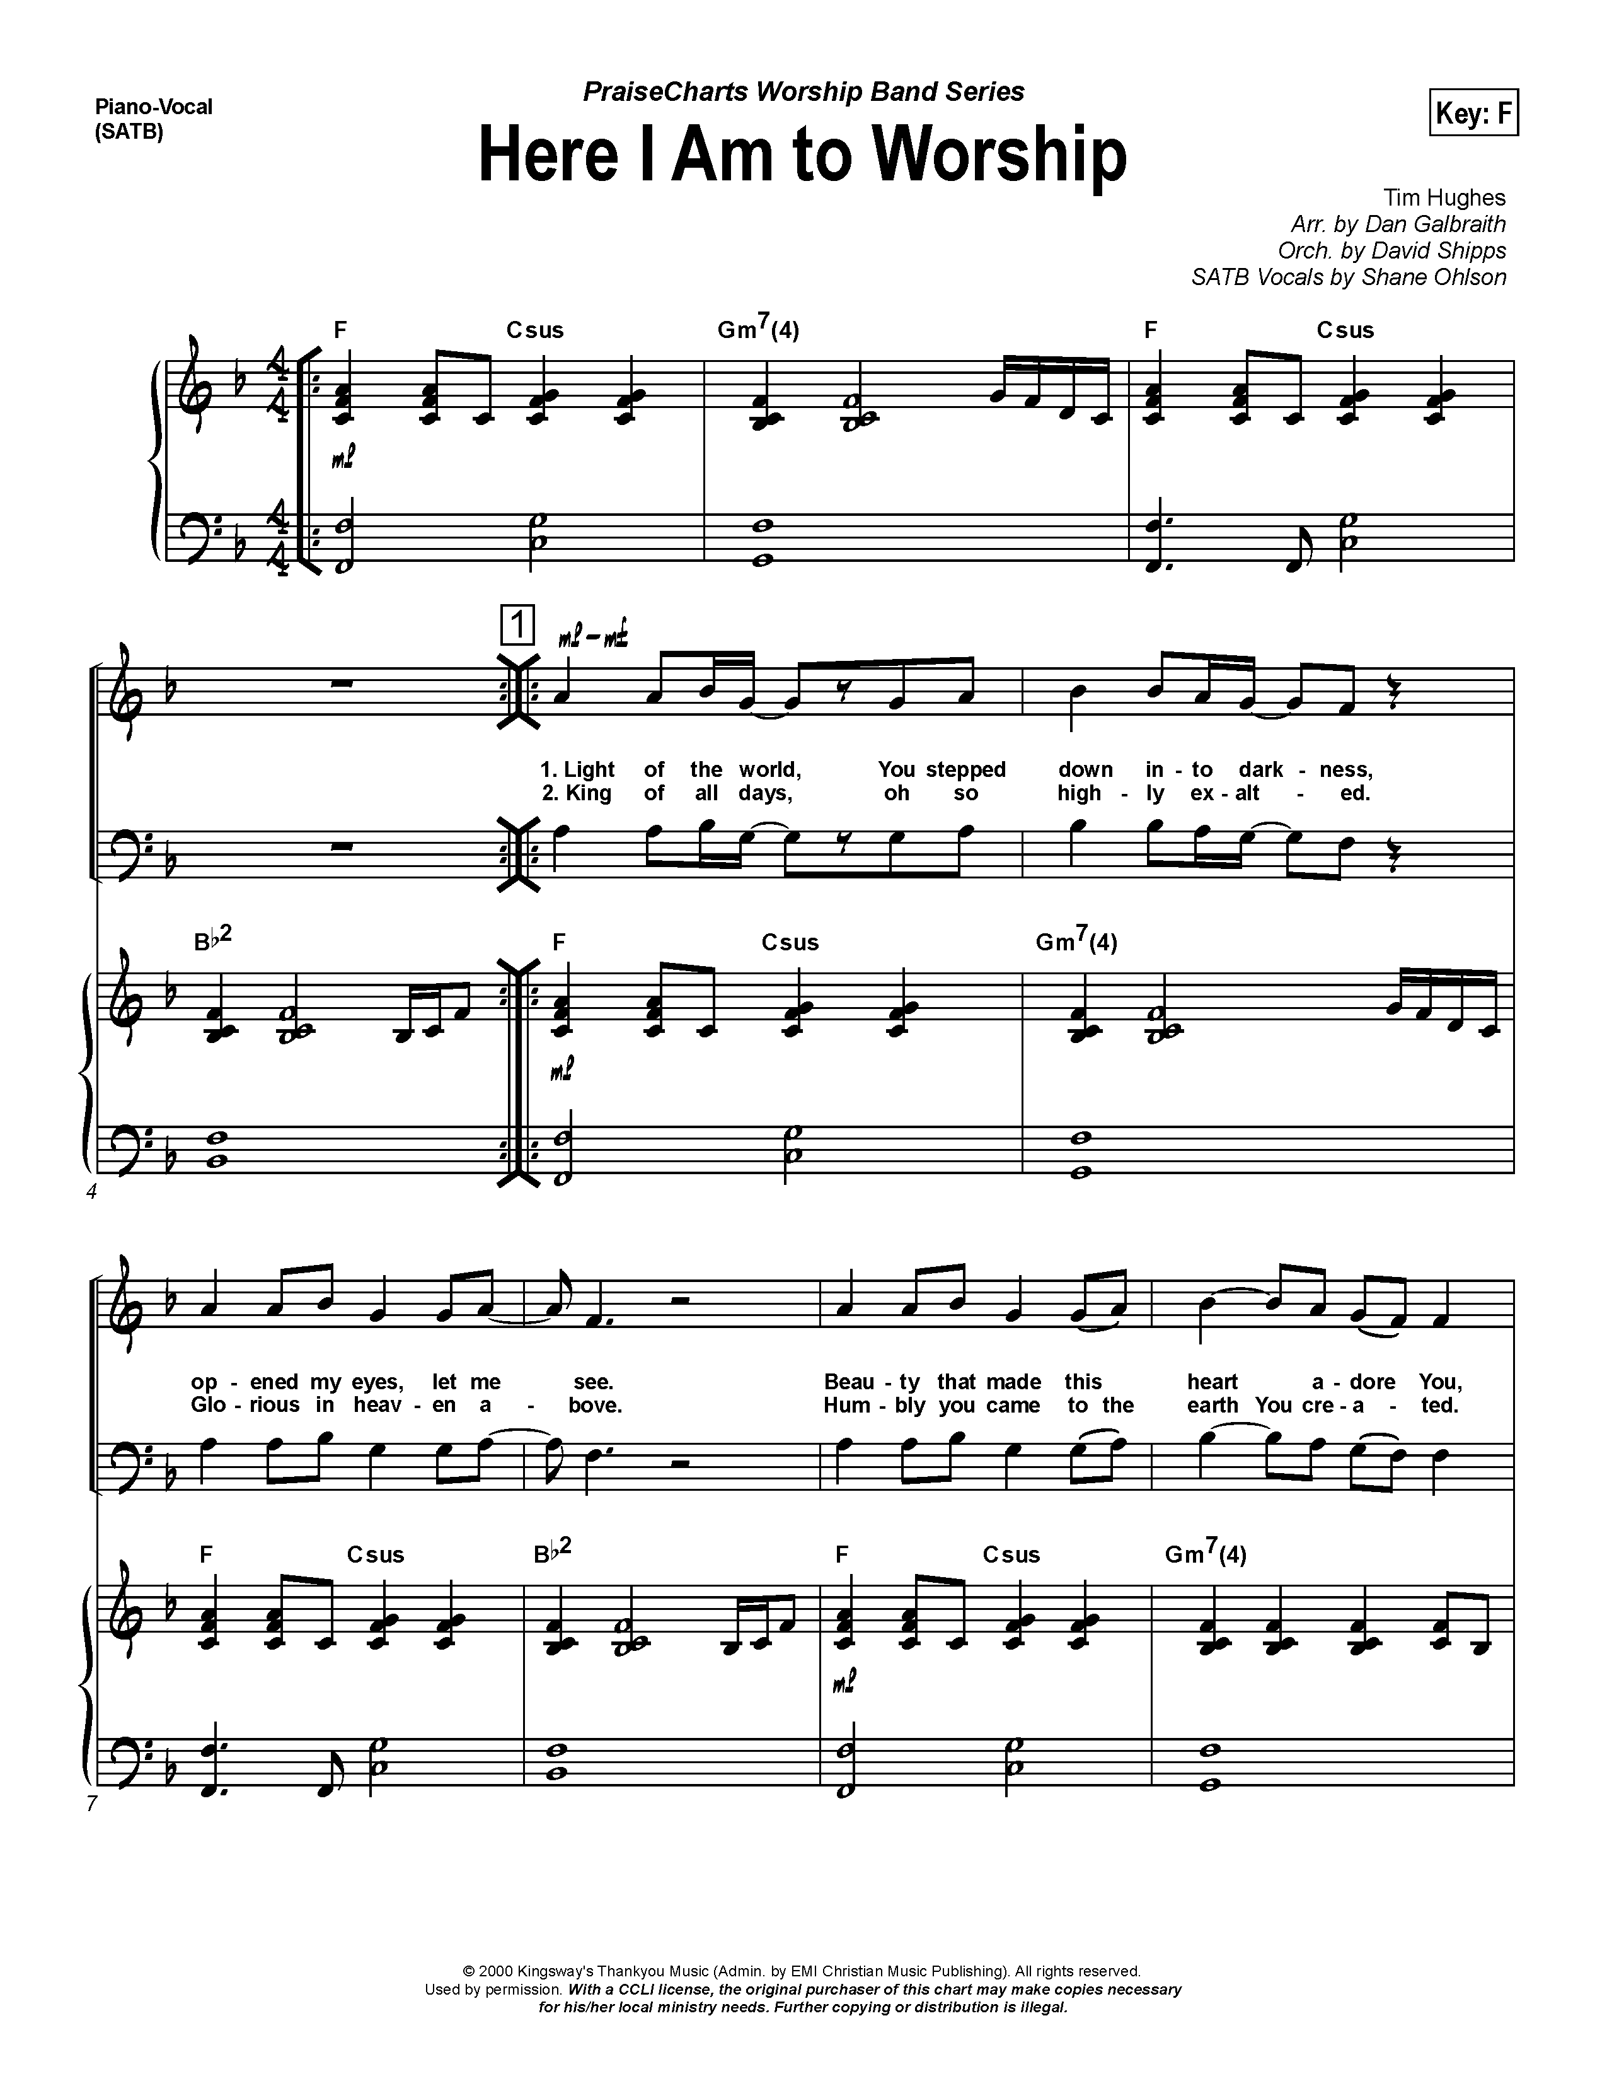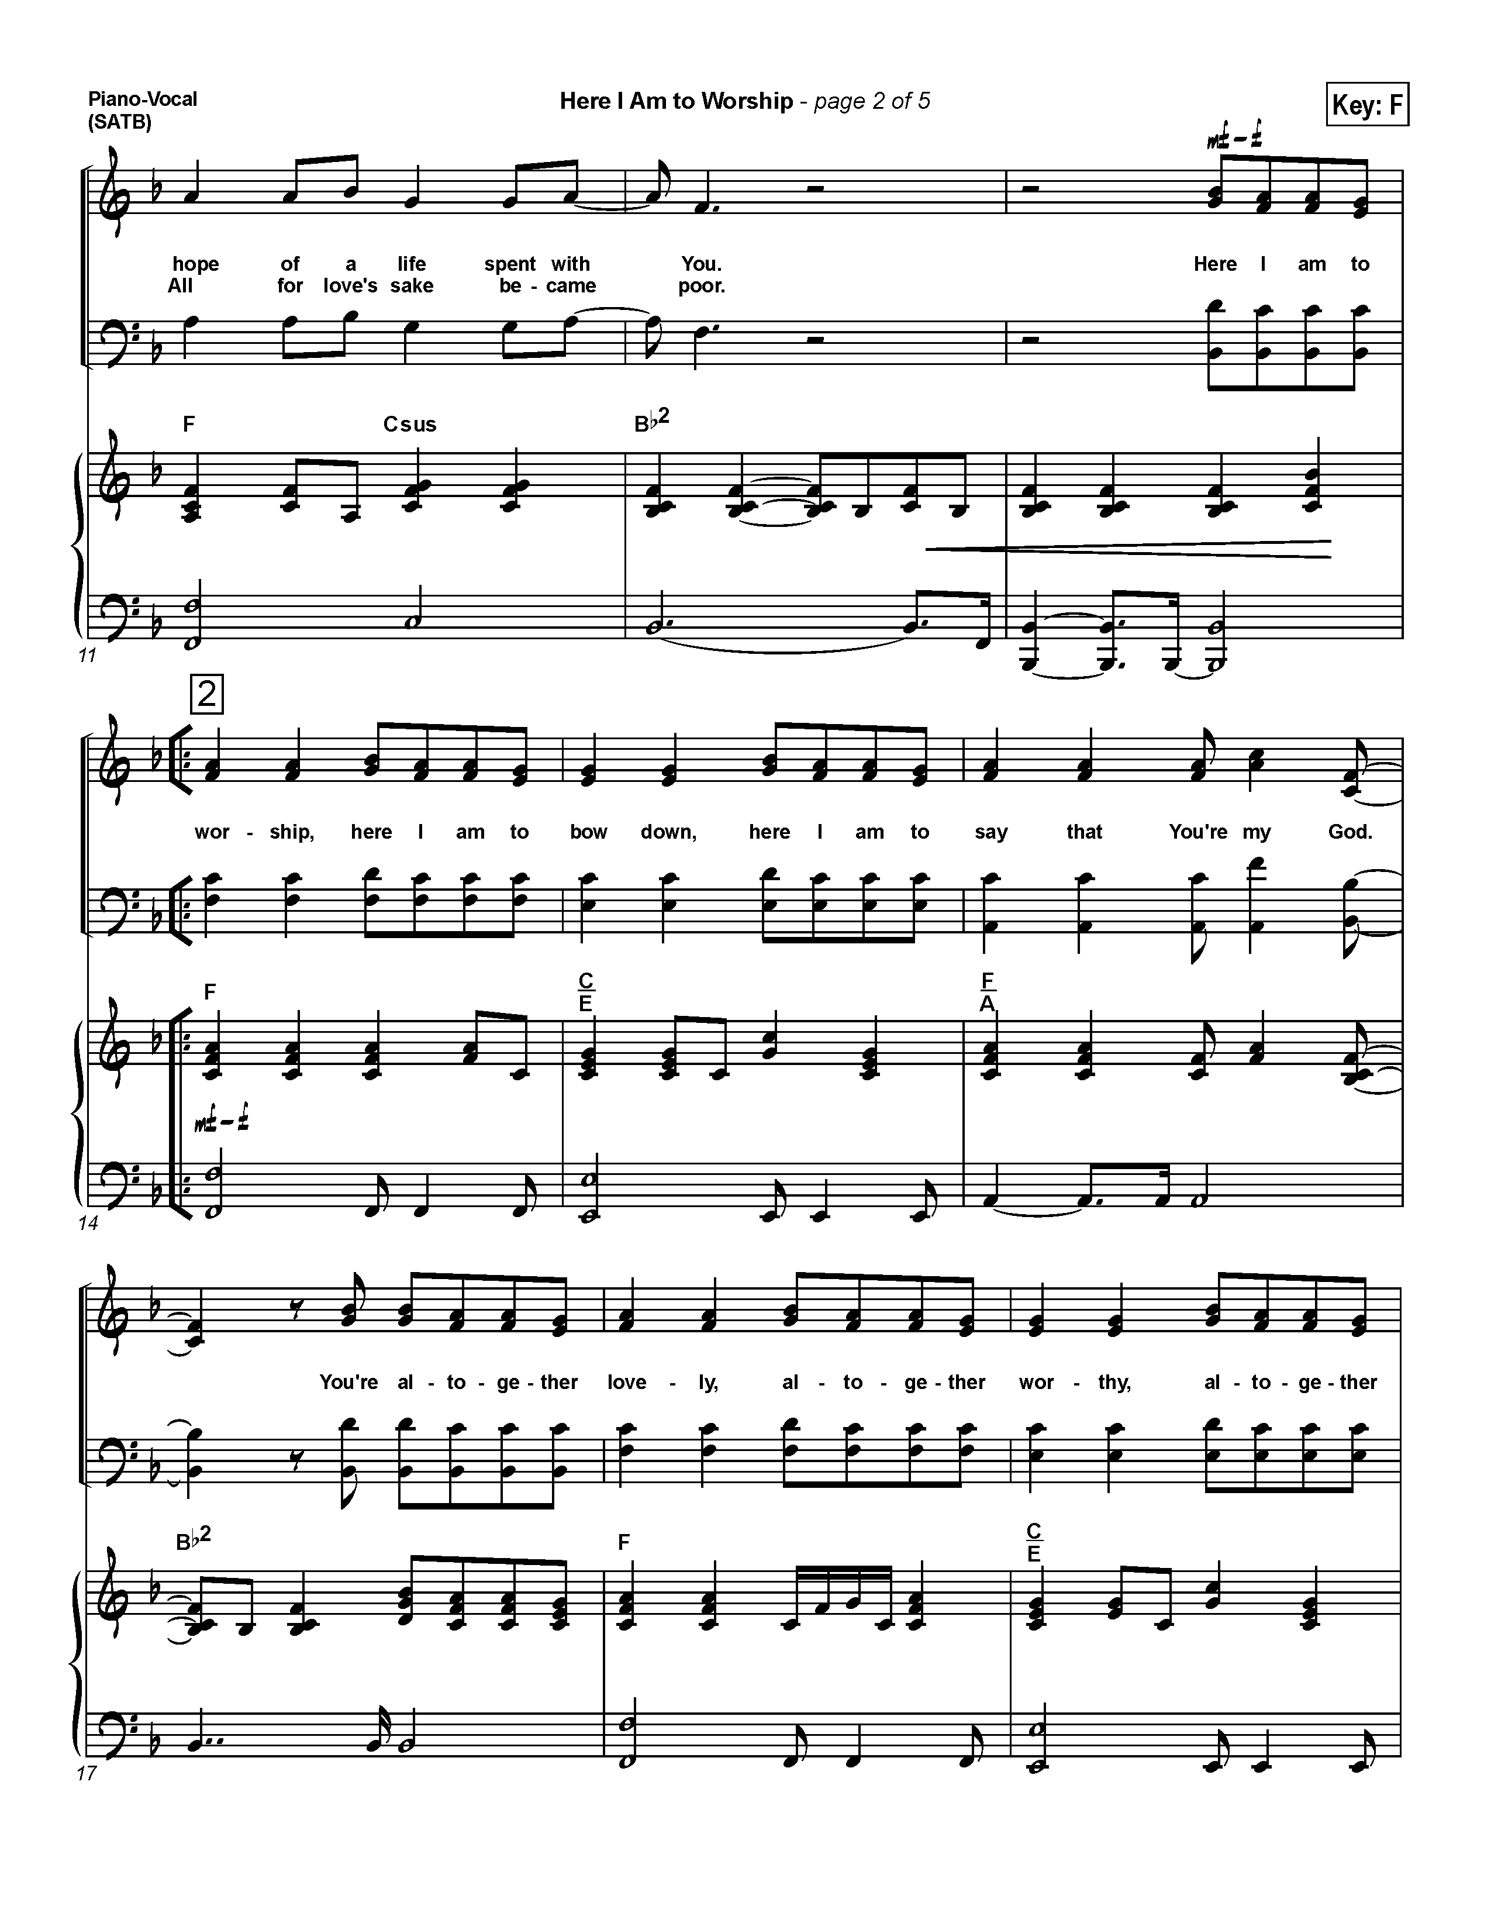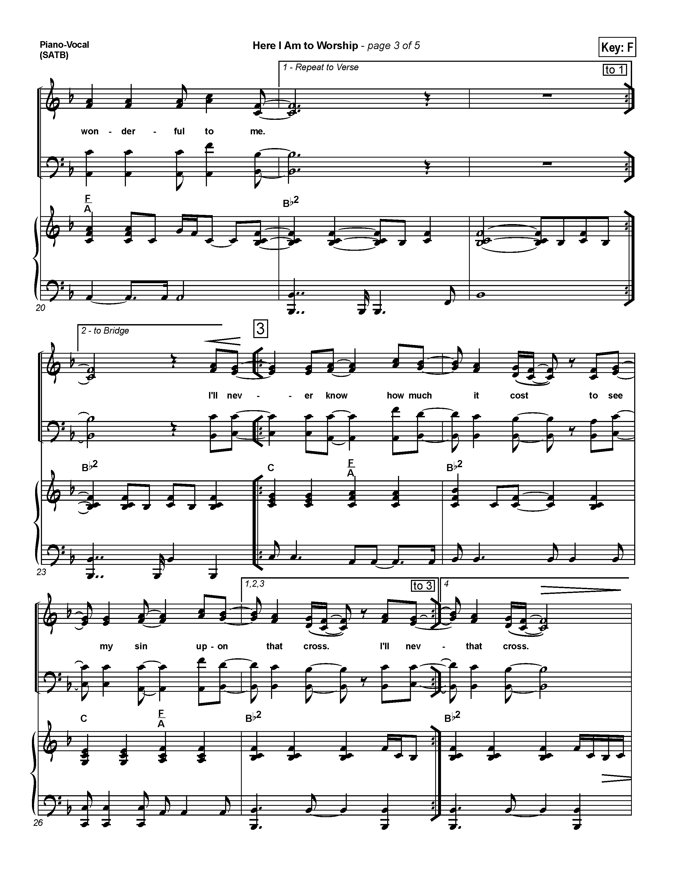

**INTROIT HYMN: Here I Am to Worship**

*Hillsong Worship*

Light of the world

You stepped down into darkness

Opened my eyes, let me see

Beauty that made this heart adore You

Hope of a life spent with You

*(refrain)*

**Here I am to worship**

**Here I am to bow down**

**Here I am to say that You're my God**

**You're altogether lovely**

**Altogether worthy**

**Altogether wonderful to me**

King of all days

Oh, so highly exalted

Glorious in heaven above

Humbly You came to the earth You created

All for love's sake became poor. ***(refrain)***

**THE COLLECT FOR THE DAY**

Let us pray,

Almighty God,

you have built your Church on the foundation of the apostles and prophets,

Jesus Christ himself being the chief cornerstone.

Join us together in unity of spirit by their teaching, that we may become a holy temple, acceptable to you; through Jesus Christ our Lord,

who lives and reigns with you and the Holy Spirit, one God, now and for ever.

**Amen.**

**THE MINISTRY OF THE WORD**

**THE FIRST READING** **Lamentations 1:1-6**  *(Marcia Lee)*

A reading from the Book of the Lamentations

How lonely sits the city that once was full of people! How like a widow she has become, she that was great among the nations! She that was a princess among the provinces has become a vassal. She weeps bitterly in the night, with tears on her cheeks; among all her lovers she has no one to comfort her; all her friends have dealt treacherously with her, they have become her enemies. Judah has gone into exile with suffering and hard servitude; she lives now among the nations, and finds no resting place; her pursuers have all overtaken her in the midst of her distress.

The roads to Zion mourn, for no one comes to the festivals; all her gates are desolate, her priests groan; her young girls grieve, and her lot is bitter.

Her foes have become the masters, her enemies prosper, because the Lord has made her suffer for the multitude of her transgressions; her children have gone away, captives before the foe. From daughter Zion has departed all her majesty. Her princes have become like stags that find no pasture; they fled without strength before the pursuer.

The Word of the Lord

**Thanks be to God**

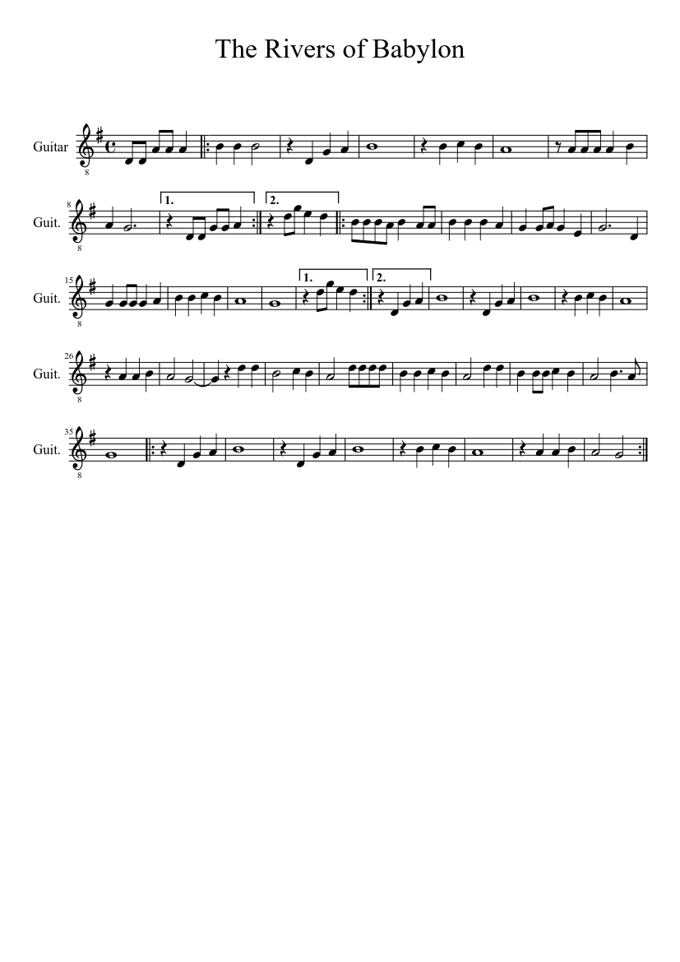

**Hymn: By the Rivers of Babylon** *(Based on Psalm 137)*

***Text:*** *H. Critchlow;* ***Tune:*** *By the Rivers of Babylon (Traditional Jamaican)*

*(chorus)*

**By the rivers of Babylon**

**There we sat down**

**Yeah, we wept**

**When we remembered Zion**

**By the rivers of Babylon**

**There we sat down**

**Yeah, we wept**

**When we remembered Zion**

When the wicked

Carried us away in captivity

Required from us a song

Now how shall we sing the Lord's song

In a strange land?

When the wicked

Carried us away in captivity

Requiring of us a song

Now how shall we sing the Lord's song

In a strange land? ***(chorus)***

Let the words of our mouth and the meditations of our heart

Be acceptable in thy sight, O our Lord

Let the words of our mouth and the meditation of our hearts

Be acceptable in thy sight O our Lord. ***(chorus)***

**THE SECOND READING 2 Timothy 1:1-14** *(Tessa Phillip)*

*A reading from the second letter of Paul to Timothy*

Paul, an apostle of Christ Jesus by the will of God, for the sake of the promise of life that is in Christ Jesus, To Timothy, my beloved child: Grace, mercy, and peace from God the Father and Christ Jesus our Lord. I am grateful to God—whom I worship with a clear conscience, as my ancestors did—when I remember you constantly in my prayers night and day. Recalling your tears, I long to see you so that I may be filled with joy.

I am reminded of your sincere faith, a faith that lived first in your grandmother Lois and your mother Eunice and now, I am sure, lives in you.

For this reason I remind you to rekindle the gift of God that is within you through the laying on of my hands; for God did not give us a spirit of cowardice, but rather a spirit of power and of love and of self-discipline. Do not be ashamed, then, of the testimony about our Lord or of me his prisoner, but join with me in suffering for the gospel, relying on the power of God, who saved us and called us with a holy calling, not according to our works but according to his own purpose and grace. This grace was given to us in Christ Jesus before the ages began, but it has now been revealed through the appearing of our Savior Christ Jesus, who abolished death and brought life and immortality to light through the gospel. For this gospel I was appointed a herald and an apostle and a teacher, and for this reason I suffer as I do. But I am not ashamed, for I know the one in whom I have put my trust, and I am sure that he is able to guard until that day what I have entrusted to him. Hold to the standard of sound teaching that you have heard from me, in the faith and love that are in Christ Jesus. Guard the good treasure entrusted to you, with the help of the Holy Spirit living in us.

The word of the Lord

**Thanks be to God**

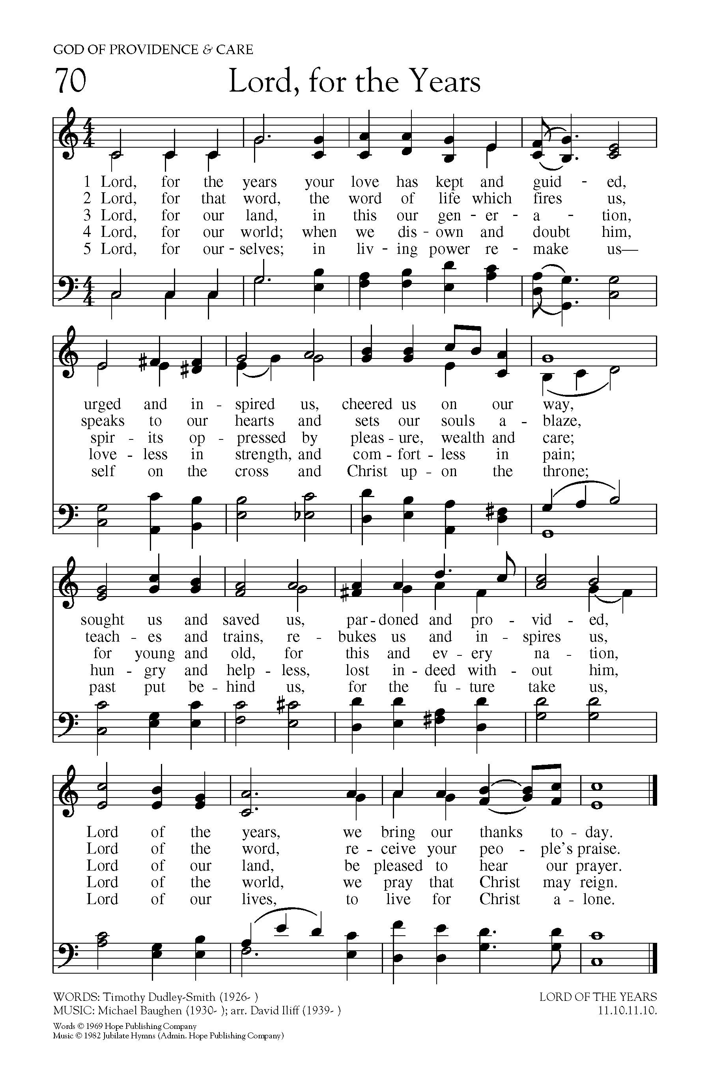

**THE GRADUAL:**  **Lord, For the Years**

**Text:** Timothy Dudley- Smith; **Tune:** LORD OF THE YEARS

Lord, for the years your love has kept and guided,

urged and inspired us, cheered us on our way,

sought us and saved us, pardoned and provided:

Lord of the years, we bring our thanks today.

Lord, for that word, the word of life which fires us,

speaks to our hearts and sets our souls ablaze,

teaches and trains, rebukes us and inspires us:

Lord of the word, receive your people's praise.

Lord, for our world; when we disown and doubt him,

loveless in strength, and comfortless in pain,

hungry and helpless, lost indeed without him:

Lord of the world, we pray that Christ may reign.

Lord for ourselves; in living power remake us —

self on the cross and Christ upon the throne,

past put behind us, for the future take us:

Lord of our lives, to live for Christ alone.

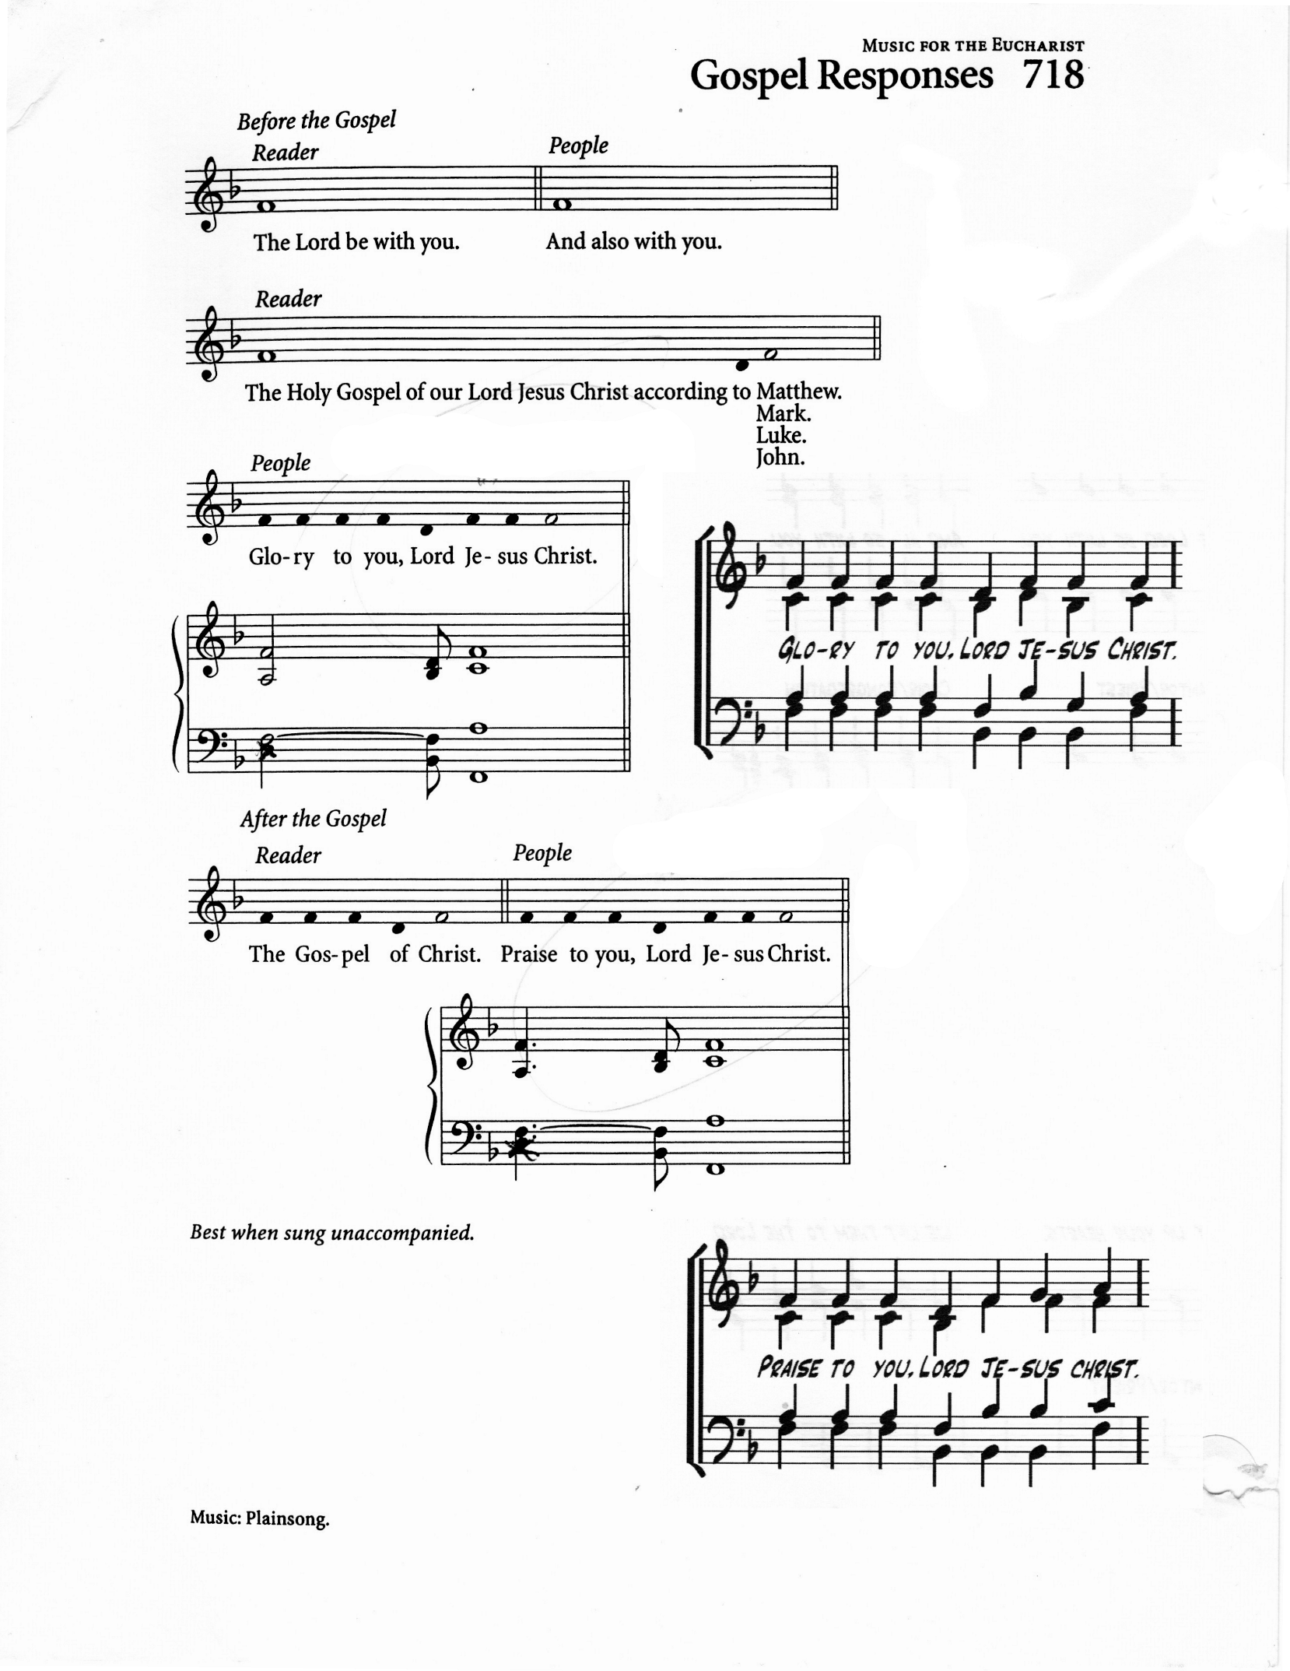

**THE HOLY GOSPEL: Luke 17:5-10** *(Ianthe Alleyne)*

The Lord be with you

**And also with you**

The Holy Gospel of our Lord Jesus Christ according to Luke

**Glory to you Lord Jesus Christ**

The apostles said to the Lord, “Increase our faith!” The Lord replied, “If you had faith the size of a mustard seed, you could say to this mulberry tree, ‘Be uprooted and planted in the sea,’ and it would obey you. “Who among you would say to your slave who has just come in from plowing or tending sheep in the field, ‘Come here at once and take your place at the table’? Would you not rather say to him, ‘Prepare supper for me, put on your apron and serve me while I eat and drink; later you may eat and drink’? Do you thank the slave for doing what was commanded? So you also, when you have done all that you were ordered to do, say, ‘We are worthless slaves; we have done only what we ought to have done!’”

The Gospel of Christ

**Praise to you, Lord Jesus Christ**

**Gospel Acclamation:** Caribbean Alleluia

**THE SERMON**

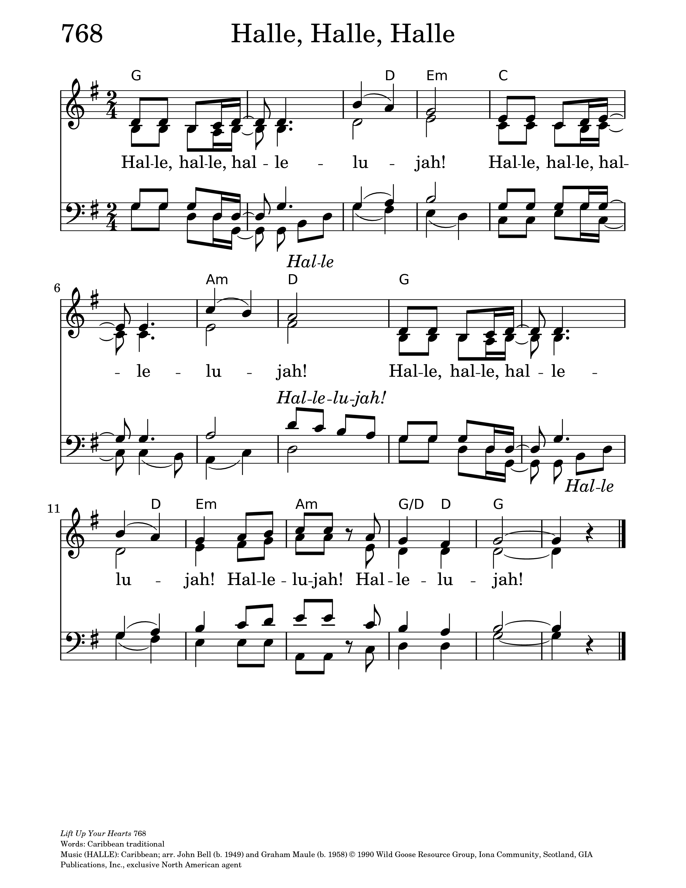

**THE APOSTLES’ CREED**

Let us confess the faith of our baptism, as we say,

**I believe in God, the Father almighty,**

**creator of heaven and earth.**

**I believe in Jesus Christ, his only Son, our Lord.**

**He was conceived by the power of the Holy Spirit**

**and born of the Virgin Mary.**

**He suffered under Pontius Pilate,**

**was crucified, died, and was buried.**

**He descended to the dead.**

**On the third day he rose again.**

**He ascended into heaven, and is seated at the right hand of the Father.**

**He will come again to judge the living and the dead.**

**I believe in the Holy Spirit, the holy catholic Church,**

**the communion of saints, the forgiveness of sins,**

**the resurrection of the body, and the life everlasting. Amen.**

**PRAYERS OF INTERCESSION:** *(Sonia Wickham)*

Let us pray,

God of justice and peace,

we lift before you nations torn apart by war, cities scarred by violence,

and communities broken by political unrest.

Stretch out your hand of healing, O Lord, and teach us the ways of peace.

God of hope,

**make all things new.**

Faithful Lord,

we pray for your Church when it falters, for its mission when it feels fragile,

and for its witness when it grows weary.

Fan into flame the gift of your Spirit, that we may serve with courage and joy.

Spirit of God,

**keep us burning bright.**

Merciful God,

remember all who suffer for the sake of what is right.

Strengthen the weary, heal the wounded,

comfort the grieving, and raise up the brokenhearted.

Let their tears be seeds of hope, and their struggles signs of your kingdom.

God of mercy,

**hold your children close.**

Creator God,

we give thanks for the work of many hands:

for businesses that provide, for labour that sustains,

for menial jobs often unseen but deeply necessary.

Bless those whose service holds our lives together.

Lord of all,

**bless the work of our hands.**

Gracious Father,

you call us to faith no bigger than a mustard seed.

When we feel small, strengthen us.

When we feel exiled, comfort us.

When we feel forgotten, remind us that we are yours.

God of faith,

**grow in us your kingdom.**

Gathering all our prayers, spoken and unspoken,

we rest them in the heart of Christ who intercedes for us.

**Amen.**

**THE CONFESSION AND ABSOLUTION**

Dear friends in Christ, God is steadfast in love and infinite in mercy;

he welcomes sinners and invites them to his table.

Let us confess our sins, confident in God’s forgiveness.

Most merciful God,

**we confess that we have sinned against you in thought, word and deed,**

**by what we have done and by what we have left undone.**

**We have not loved you with our whole heart;**

**we have not loved our neighbours as ourselves.**

**We are truly sorry and we humbly repent.**

**For the sake of your Son Jesus Christ, have mercy on us and forgive us,**

**that we may delight in your will, and walk in your ways,**

**to the glory of your name.  Amen.**

Almighty God have mercy upon you, pardon and deliver you from all your sins,

confirm and strengthen you in all goodness, and keep you in eternal life;

through Jesus Christ our Lord.

**Amen.**

***The Peace***

The peace of the Lord be always with you.

**And also with you.**

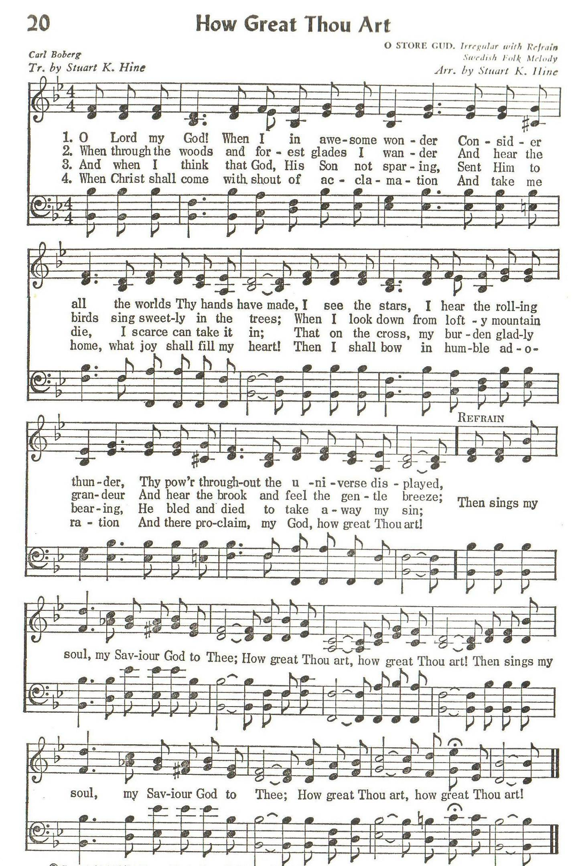

**OFFERTORY: How Great Thou Art**

***Text:*** *Stuart K. Hine****; Tune:*** *O STORE GUD*

O Lord my God, when I in awesome wonder

Consider all the worlds thy hands have made,

I see the stars, I hear the rolling thunder,

Thy power throughout the universe displayed:

*(refrain)*

**Then sings my soul, my Saviour God, to thee:**

**How great thou art! How great thou art!**

**Then sings my soul, my Saviour God, to thee:**

**How great thou art! How great thou art!**

When through the woods and forest glades I wander

And hear the birds sing sweetly in the trees,

When I look down from lofty mountain grandeur,

And hear the brook and feel the gentle breeze:***(refrain)***

And when I think that God, his Son not sparing,

Sent him to die, I scarce can take it in,

That on the cross, my burden gladly bearing,

He bled and died to take away my sin. ***(refrain)***

When Christ shall come with shout of acclamation

And take me home, what joy shall fill my heart!

Then I shall bow in humble adoration,

And there proclaim, My God, how great thou art! ***(refrain)***

**PRAYER OVER THE GIFTS**

**God of truth, receive all we offer you this day.**

**Make us worthy servants, strong to follow in the pattern**

**of our Lord and Saviour Jesus Christ. Amen.**

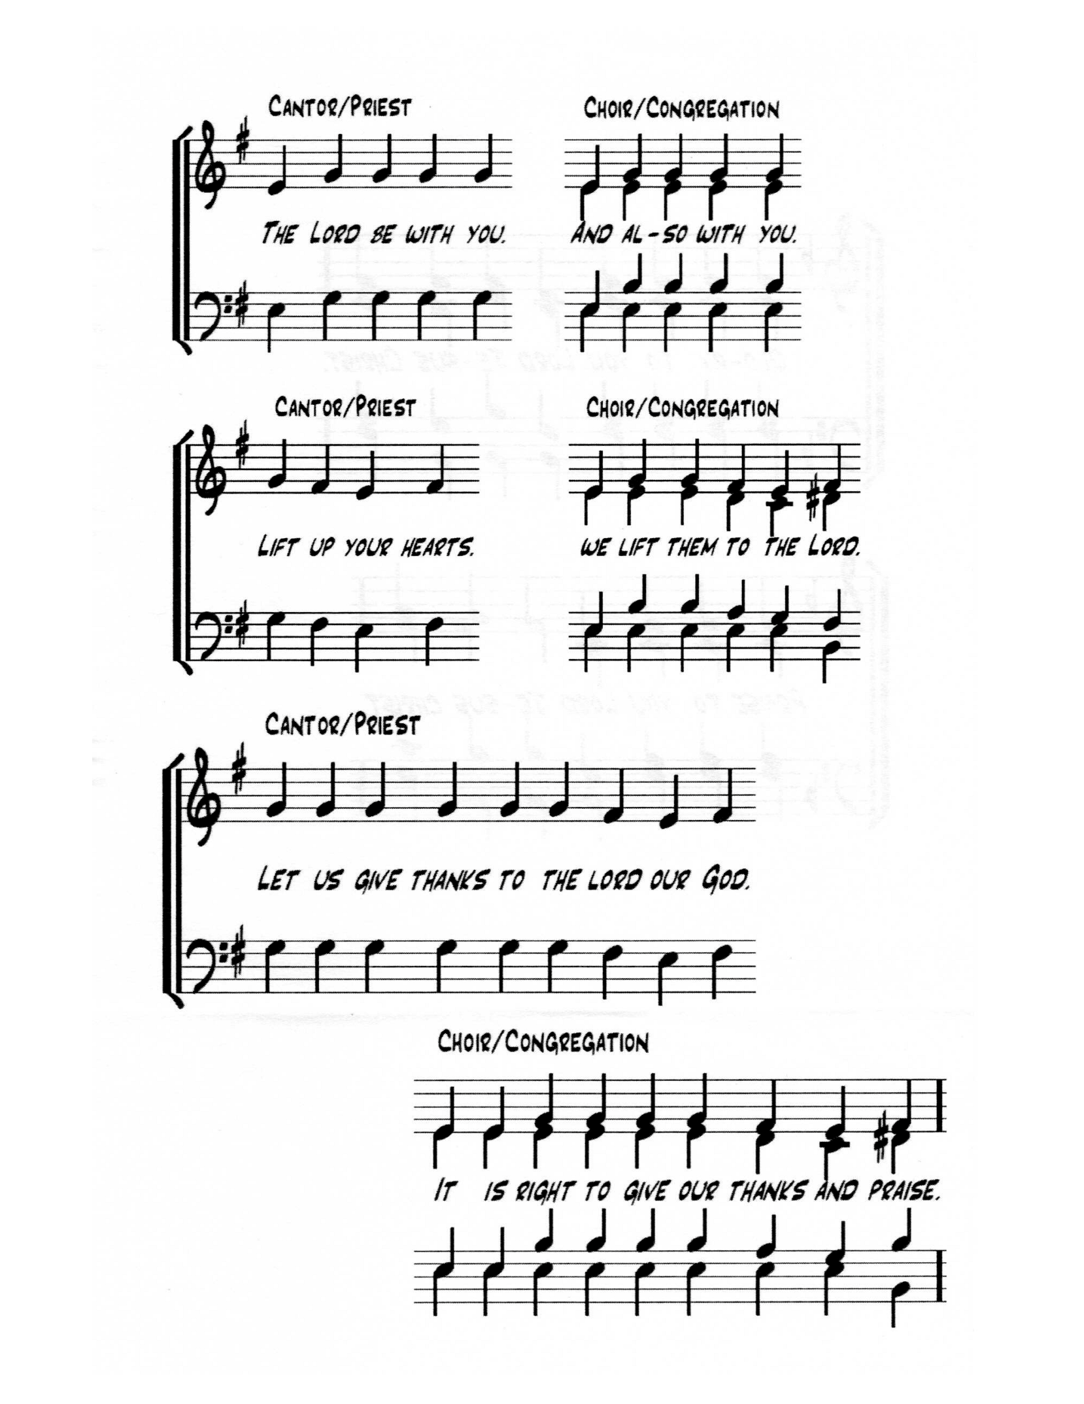

**THE EUCHARISTIC PRAYER**

The Lord be with you.

**And also with you.**

Lift up your hearts.

**We lift them to the Lord.**

Let us give thanks to the Lord our God.

**It is right to give our thanks and praise.**

God, you are limitless—your love has no boundaries,

your power has no end, your mercy has no finish line.

You made the world wide and wonderful,

and you breathe life into all people.

Now with all creation we raise our voices

to proclaim the glory of your name.

**Holy, holy, holy Lord,**

**God of power and might,**

**heaven and earth are full of your glory.**

**Hosanna in the highest.**

**Blessed is he who comes in the name of the Lord.**

**Hosanna in the highest.**

When we wandered away, you never stopped chasing us.

You sent prophets, dreamers, and teachers to call us back to you.

And when the time was right, you sent Jesus—our Saviour, Friend, and Brother.

He healed the broken, welcomed the outsider, and set people free.  
He showed us how big your love really is.

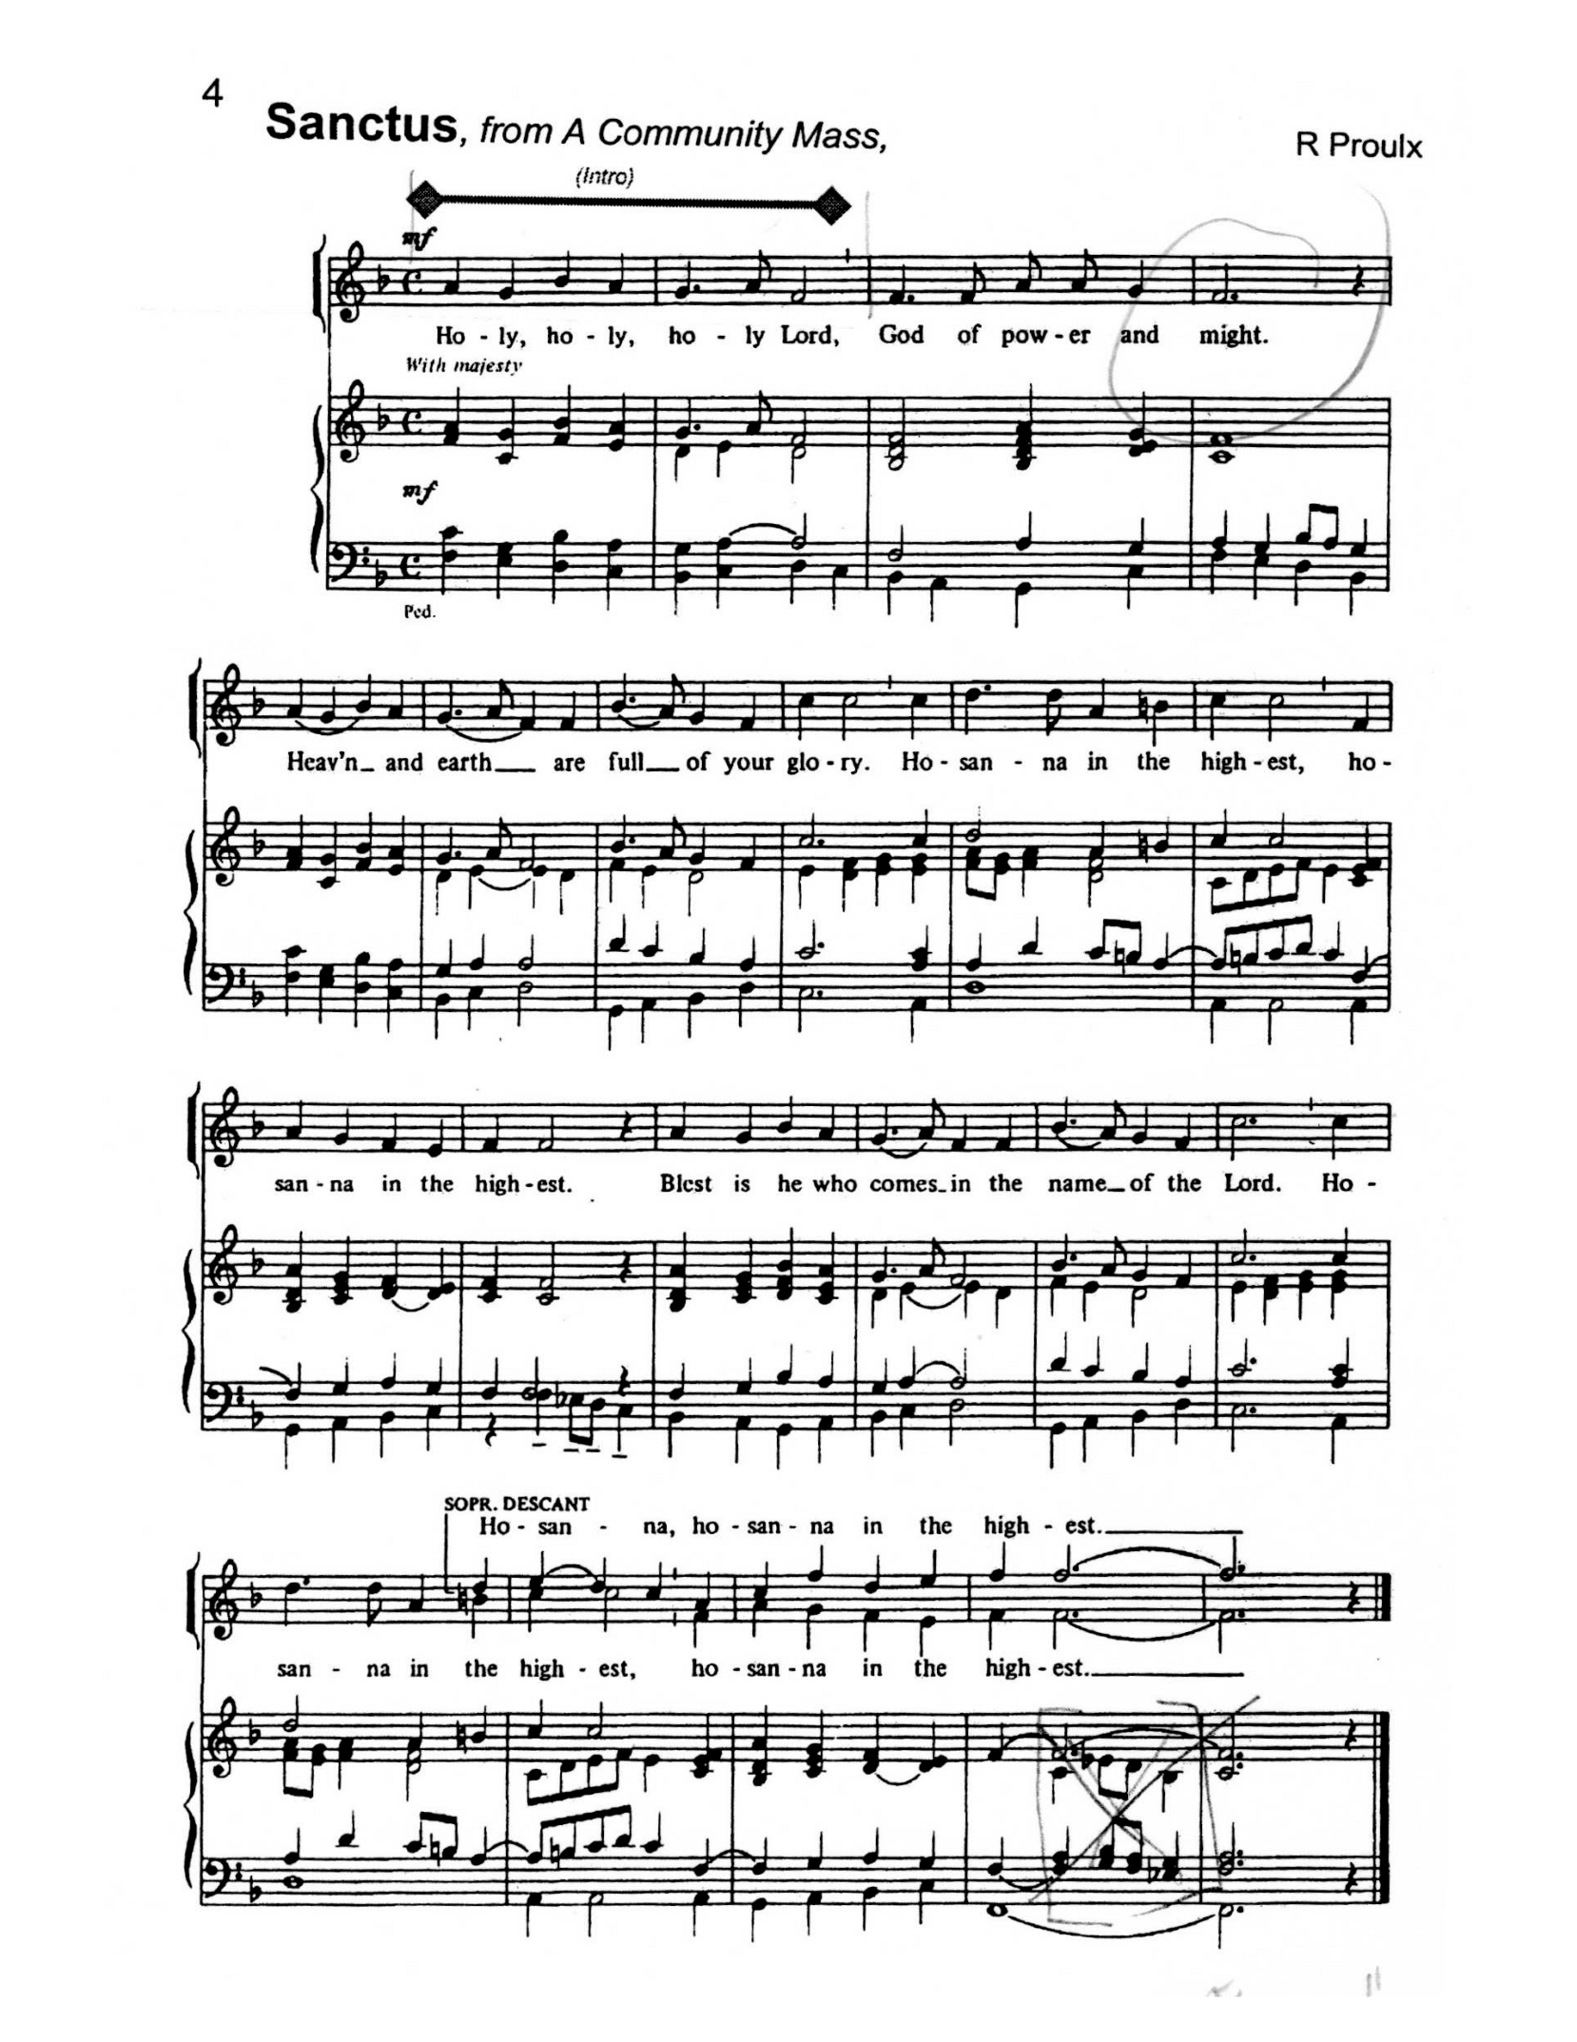

On the night before he gave his life, Jesus took bread, gave you thanks,  
broke it, and shared it with his friends, saying:  
“Take, eat; this is my body given for you.  
Do this to remember me.”

Then he took the cup, gave you thanks, and said:  
“Drink this, all of you.  
This is my blood poured out for you—forgiveness without limit.  
Do this to remember me.”

Let us proclaim the mystery of faith

**Chrst has died. Christ is risen. Christ will come again.**

Send your Holy Spirit on us and on this bread and wine.

Make them signs of Jesus’ endless life,

and fill us with your fire, so we may be light-bearers—

setting our churches and communities on fire with love.

Through Jesus, with Jesus, in Jesus, by the power of your Spirit,  
we worship you, Limitless God—today and forever.

**Amen!**

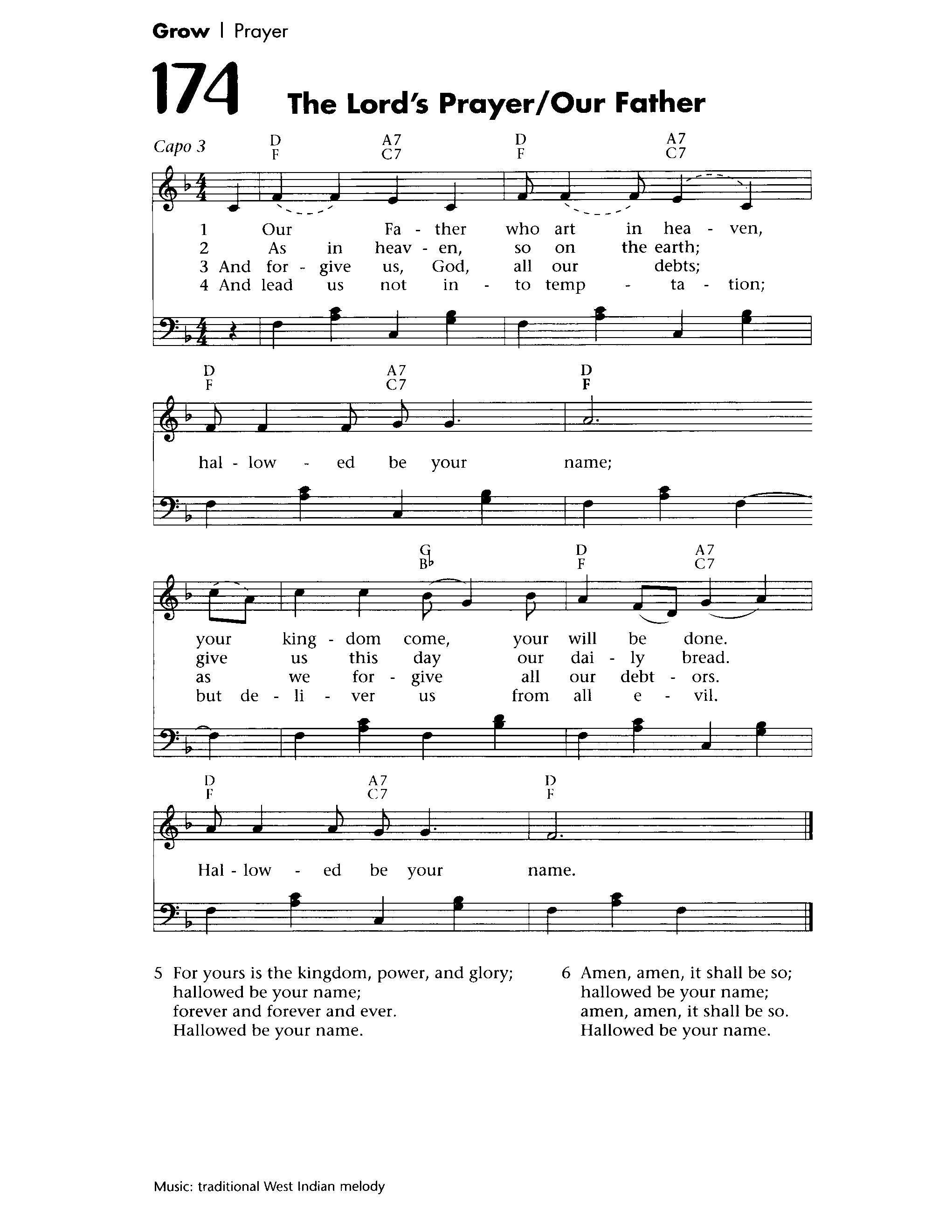

**THE LORD’S PRAYER** *(West Indian)*

And now, as our Saviour Christ has taught us, we are bold to sing.

Our Father, who art in heaven, **hallowed be Thy name.**

Thy kingdom come, Thy will be done, **hallowed be Thy name,**

On the earth as it is in heaven, **hallowed be Thy name.**

Give us this day our daily bread, **hallowed be Thy name,**

Forgive us all our trespasses, **hallowed be Thy name,**

As we forgive those who trespass against us, **hallowed be Thy name,**

And lead us not into temptation, **hallowed be Thy name,**

But deliver us from all that is evil, **hallowed be Thy name,**

For thine is the kingdom, the power and the glory, **hallowed be Thy name.**

Forever and ever, forever and ever, **hallowed be Thy name,**

Amen, Amen, it shall be so, **hallowed be Thy name.**

Amen, Amen, it shall be so, **hallowed be Thy name.**

**THE BREAKING OF THE BREAD**

We break this bread to share in the body of Christ.

**We, being many, are one body, for we all share in the one bread.**

**THE INVITATION**

The gifts of God for the People of God

**Thanks be to God.**

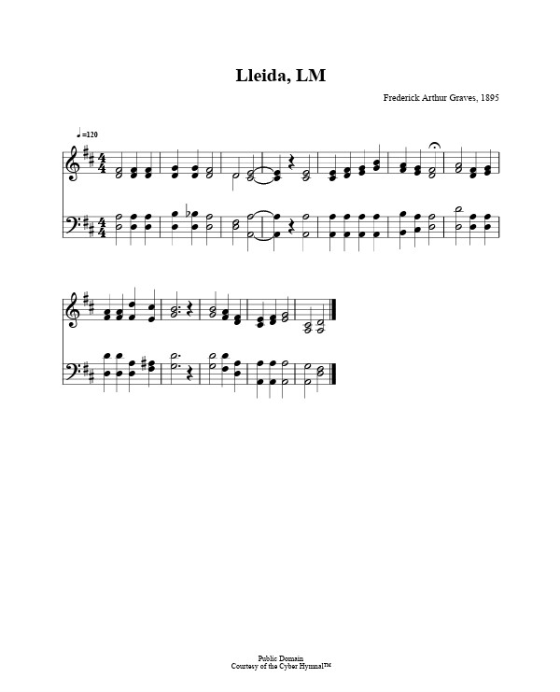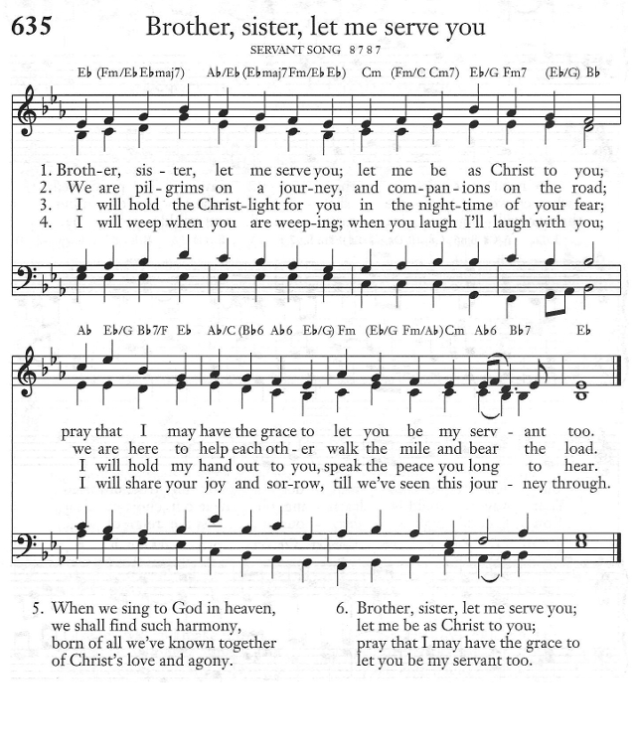

**DURING COMMUNION: Brother, Sister, Let Me Serve You**

***Text:*** *Richard A. M. Gillard****; Tune:*** *SERVANT SONG*

Brother, sister, let me serve you;

let me be as Christ to you;

pray that I may have the grace to

let you be my servant too.

We are pilgrims on a journey,

and companions on the road;

we are here to help each other

walk the mile and bear the load.

I will hold the Christlight for you

in the night-time of your fear;

I will hold my hand out to you,

speak the peace you long to hear.

When we sing to God in heaven,

we shall find such harmony,

born of all we've known together

of Christ's love and agony.

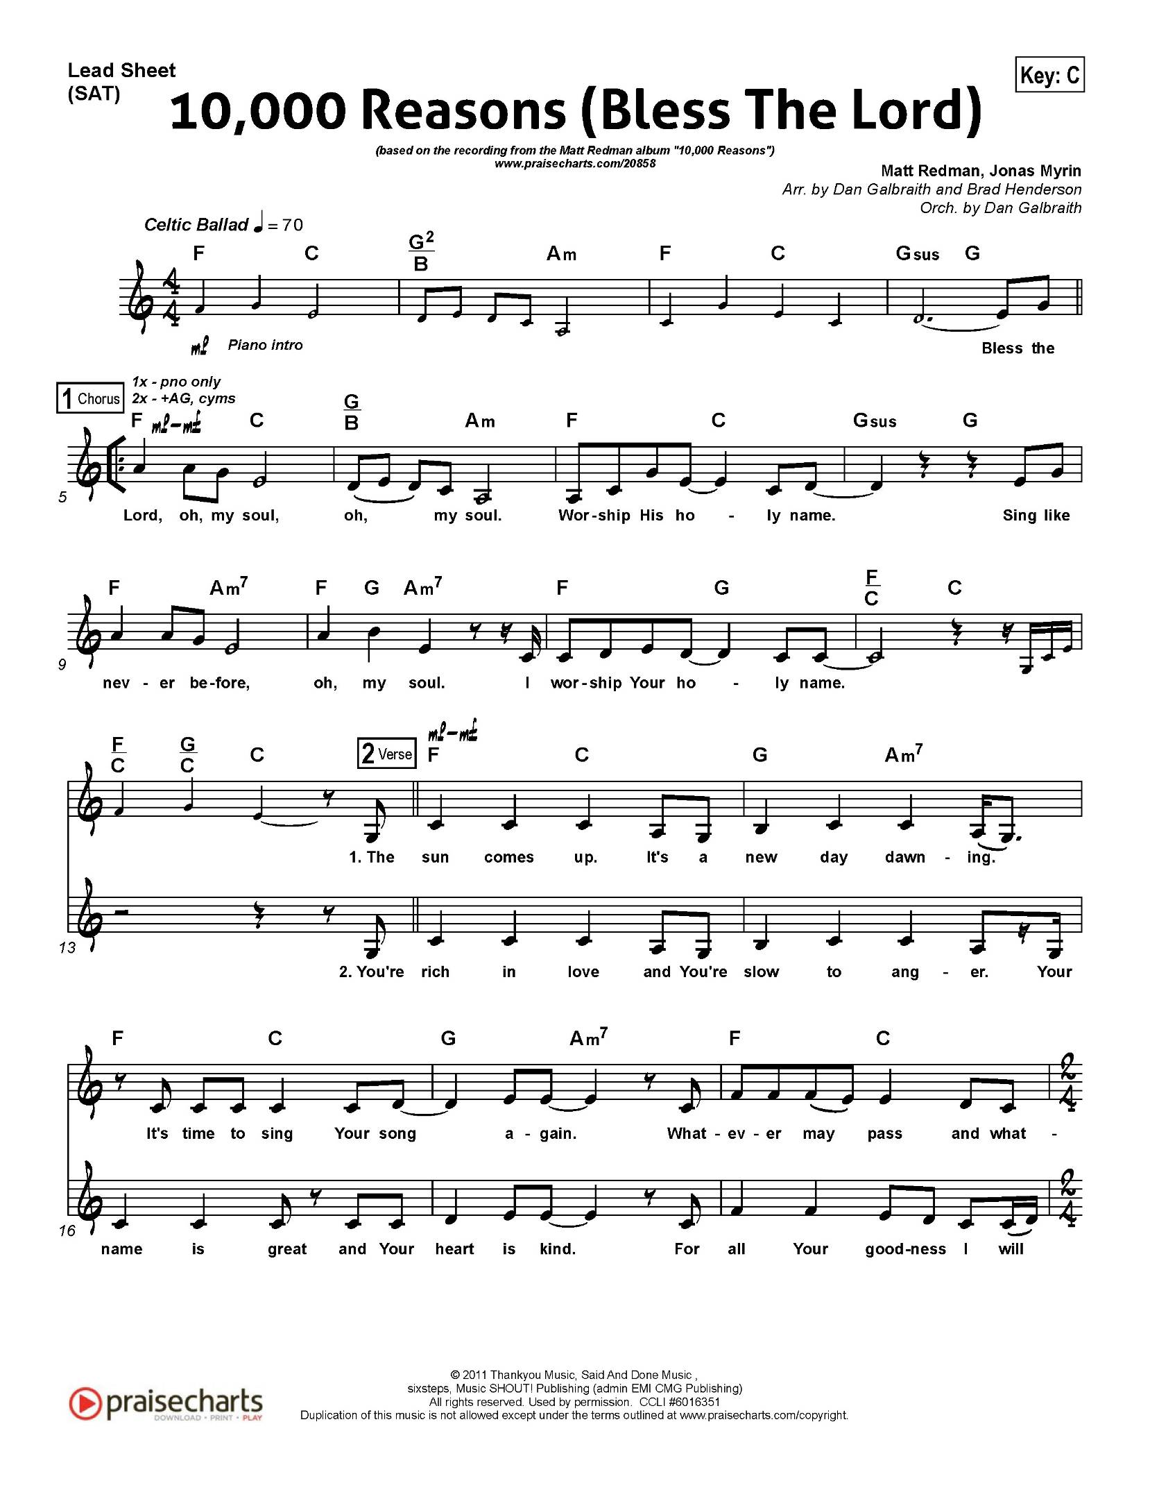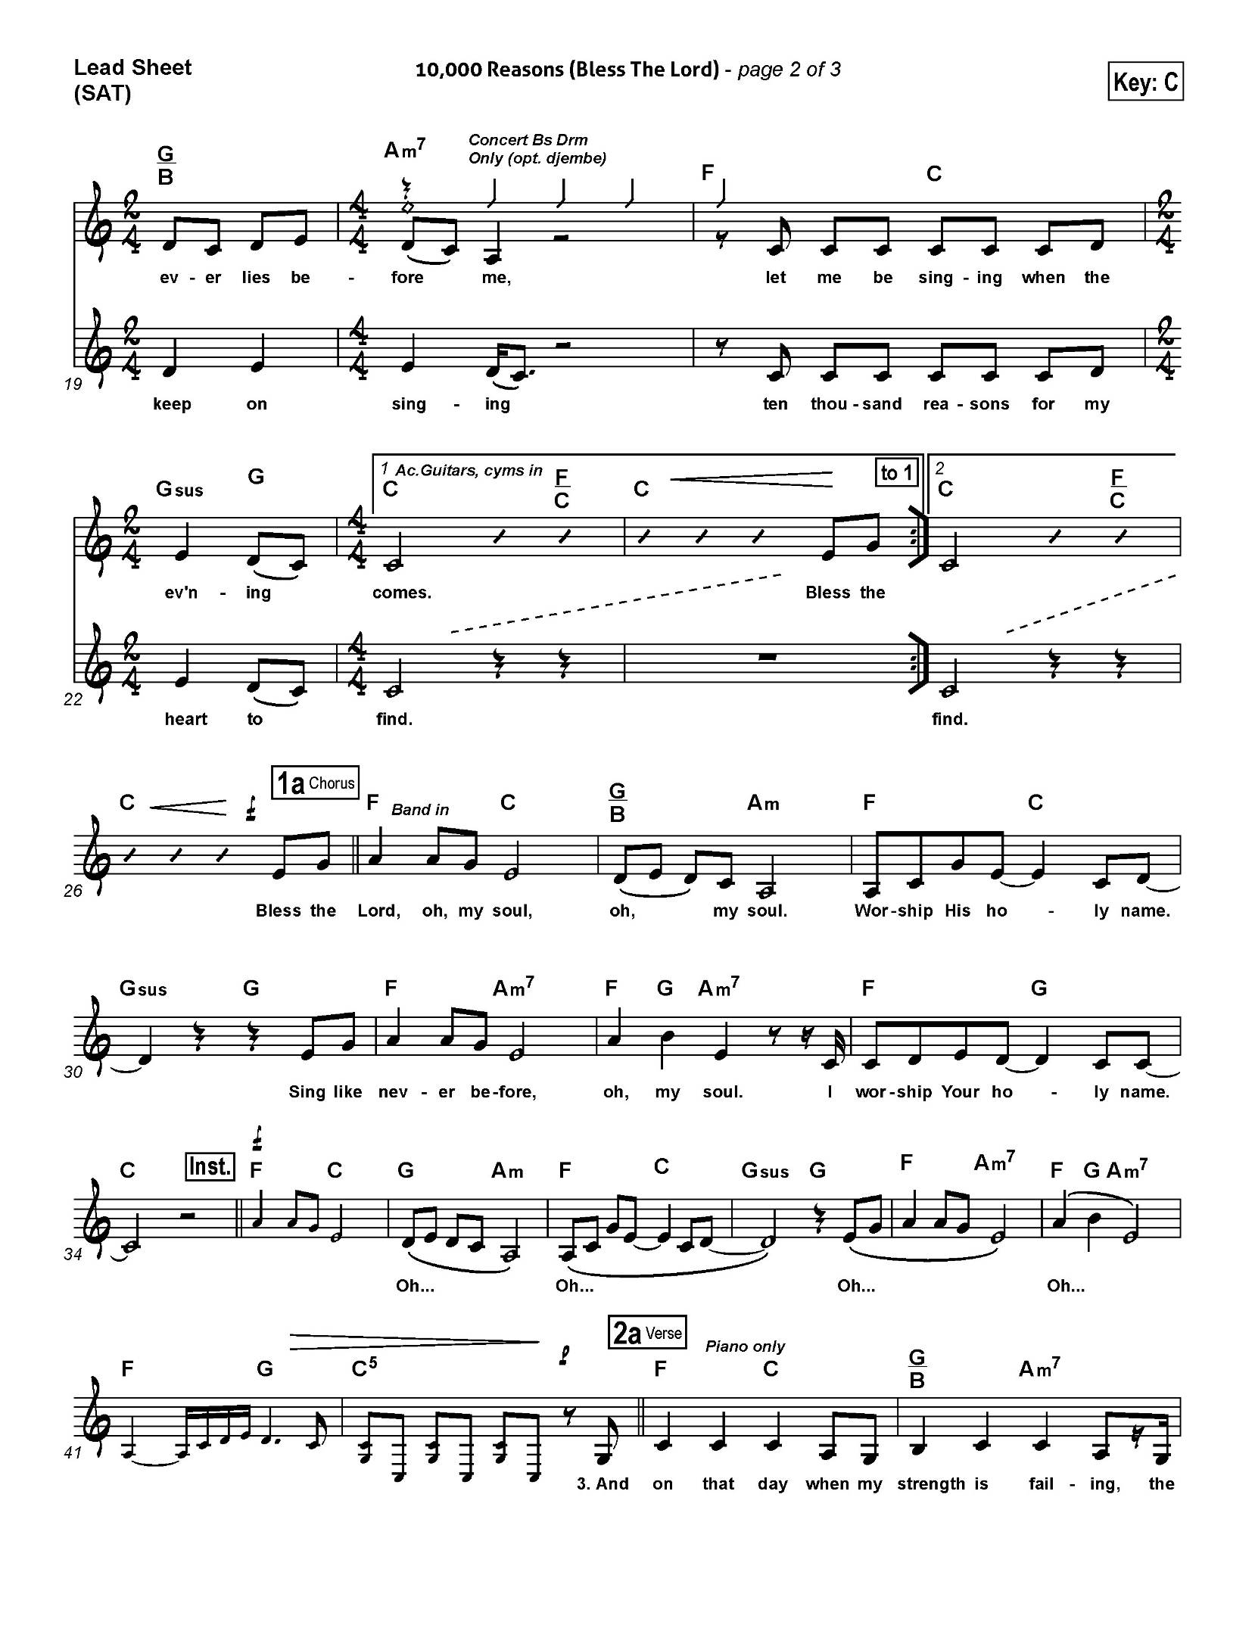

**Ablutions:** **10,000 Reasons**

***Text & Music:*** *Matt Redman*

*(refrain)*

**Bless the Lord, O my soul, O my soul**

**Worship His holy name**

**Sing like never before, O my soul**

**I'll worship Your holy name**

The sun comes up, it's a new day dawning

It's time to sing Your song again

Whatever may pass and whatever lies before me

Let me be singing when the evening comes*.* ***(refrain)***

You're rich in love and You're slow to anger

Your name is great and Your heart is kind

For all Your goodness, I will keep on singing

Ten thousand reasons for my heart to find. ***(refrain)***

**PRAYER AFTER COMMUNION**

**Almighty God,**

**may we who have been strengthened by this eucharist**

**remain in your steadfast love,**

**and show in our lives the saving mystery that we celebrate.**

**This we ask in the name of Jesus Christ the Lord.**

**Amen.**

**THE BLESSING:**

Go forth in mustard-seed faith,

in Spirit-given power,

and in Christ-shaped service.

And the blessing of God Almighty, the Father, the Son,

and the Holy Spirit be with you now and always.

**Amen.**

***ANNOUNCEMENTS:***

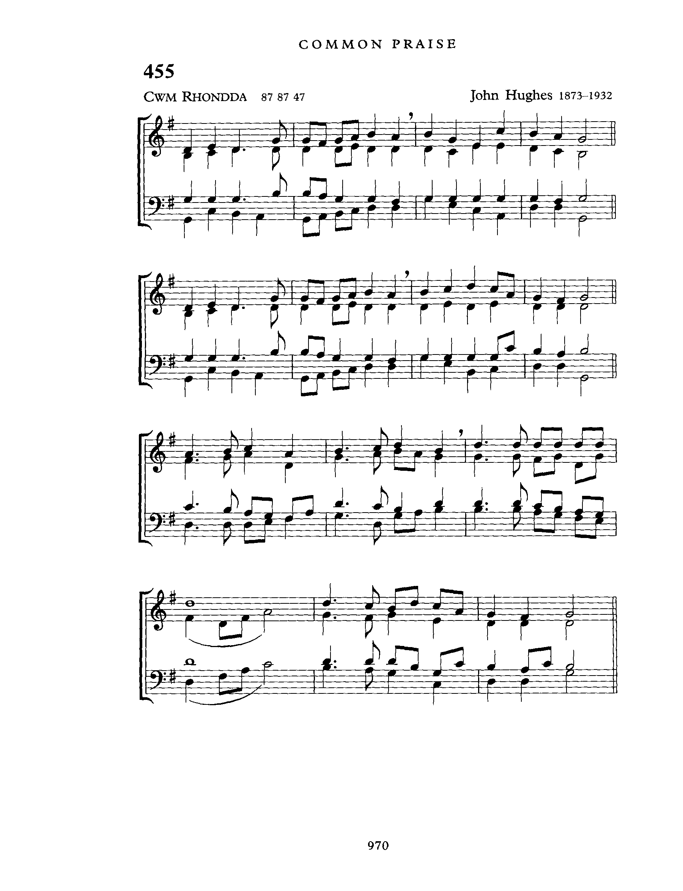

**RECESSIONAL:** **Guide me, O thou Great Jehovah**

***Text:*** *William Williams;* ***Tune:*** *CWM RHONDDA*

Guide me, O my great Redeemer,

pilgrim through this barren land;

I am weak, but you are mighty;

hold me with your powerful hand.

Bread of heaven, bread of heaven,

feed me now and evermore,

feed me now and evermore.

Open now the crystal fountain,

where the healing waters flow.

Let the fire and cloudy pillar

lead me all my journey through.

Strong Deliverer, strong Deliverer,

ever be my strength and shield,

ever be my strength and shield.

When I tread the verge of Jordan,

bid my anxious fears subside.

Death of death, and hell's Destruction,

land me safe on Canaan's side.

Songs of praises, songs of praises

I will ever sing to you,

I will ever sing to you.

**The Dismissal:**

Followers of Christ, Inspired by the Holy Spirit.

Serve the world God loves. Alleluia! Alleluia!

**Thanks be to God. Alleluia! Alleluia!**

**POSTLUDE:** We Are Marching in the Light of God

**(Siyahamba)**

