

The Last Sunday after Pentecost

The Reign of Christ

Sung Eucharist with Anointing

November 23, 2025, 10:30am

Website: www.sthildasanglicanchurch.com
Church Email: info@sthildasanglicanchurch.com
Facebook: St. Hilda’s Fairbank Anglican Church

Incumbent: Kenute Francis (437-488-9657)

kenute@sthildasanglicanchurch.com

Eucharistic Ministers: Ianthe, William & Errol

Organist: William “Bill” Khan

Crucifer: Kishmar Miller

1st Reading: Joan Tait

2nd Reading: Jonathan Small

The Gospel: William Greenidge

Intercession: Neville Lowe

Tech Team: Temia Maharaj

Ushers Team 1: Jean Caine Christine Fleming

Elfreda Garriques Neville Lowe

Beverley Beckford Dione Robertson

Marcia Lee Hildred Small

MISSION STATEMENT
The purpose of St. Hilda’s Church is to be Christ-centered in our life and worship,
to serve lovingly those within our family and others within our reach

that the spirit of God might empower us for worship and pastoral care

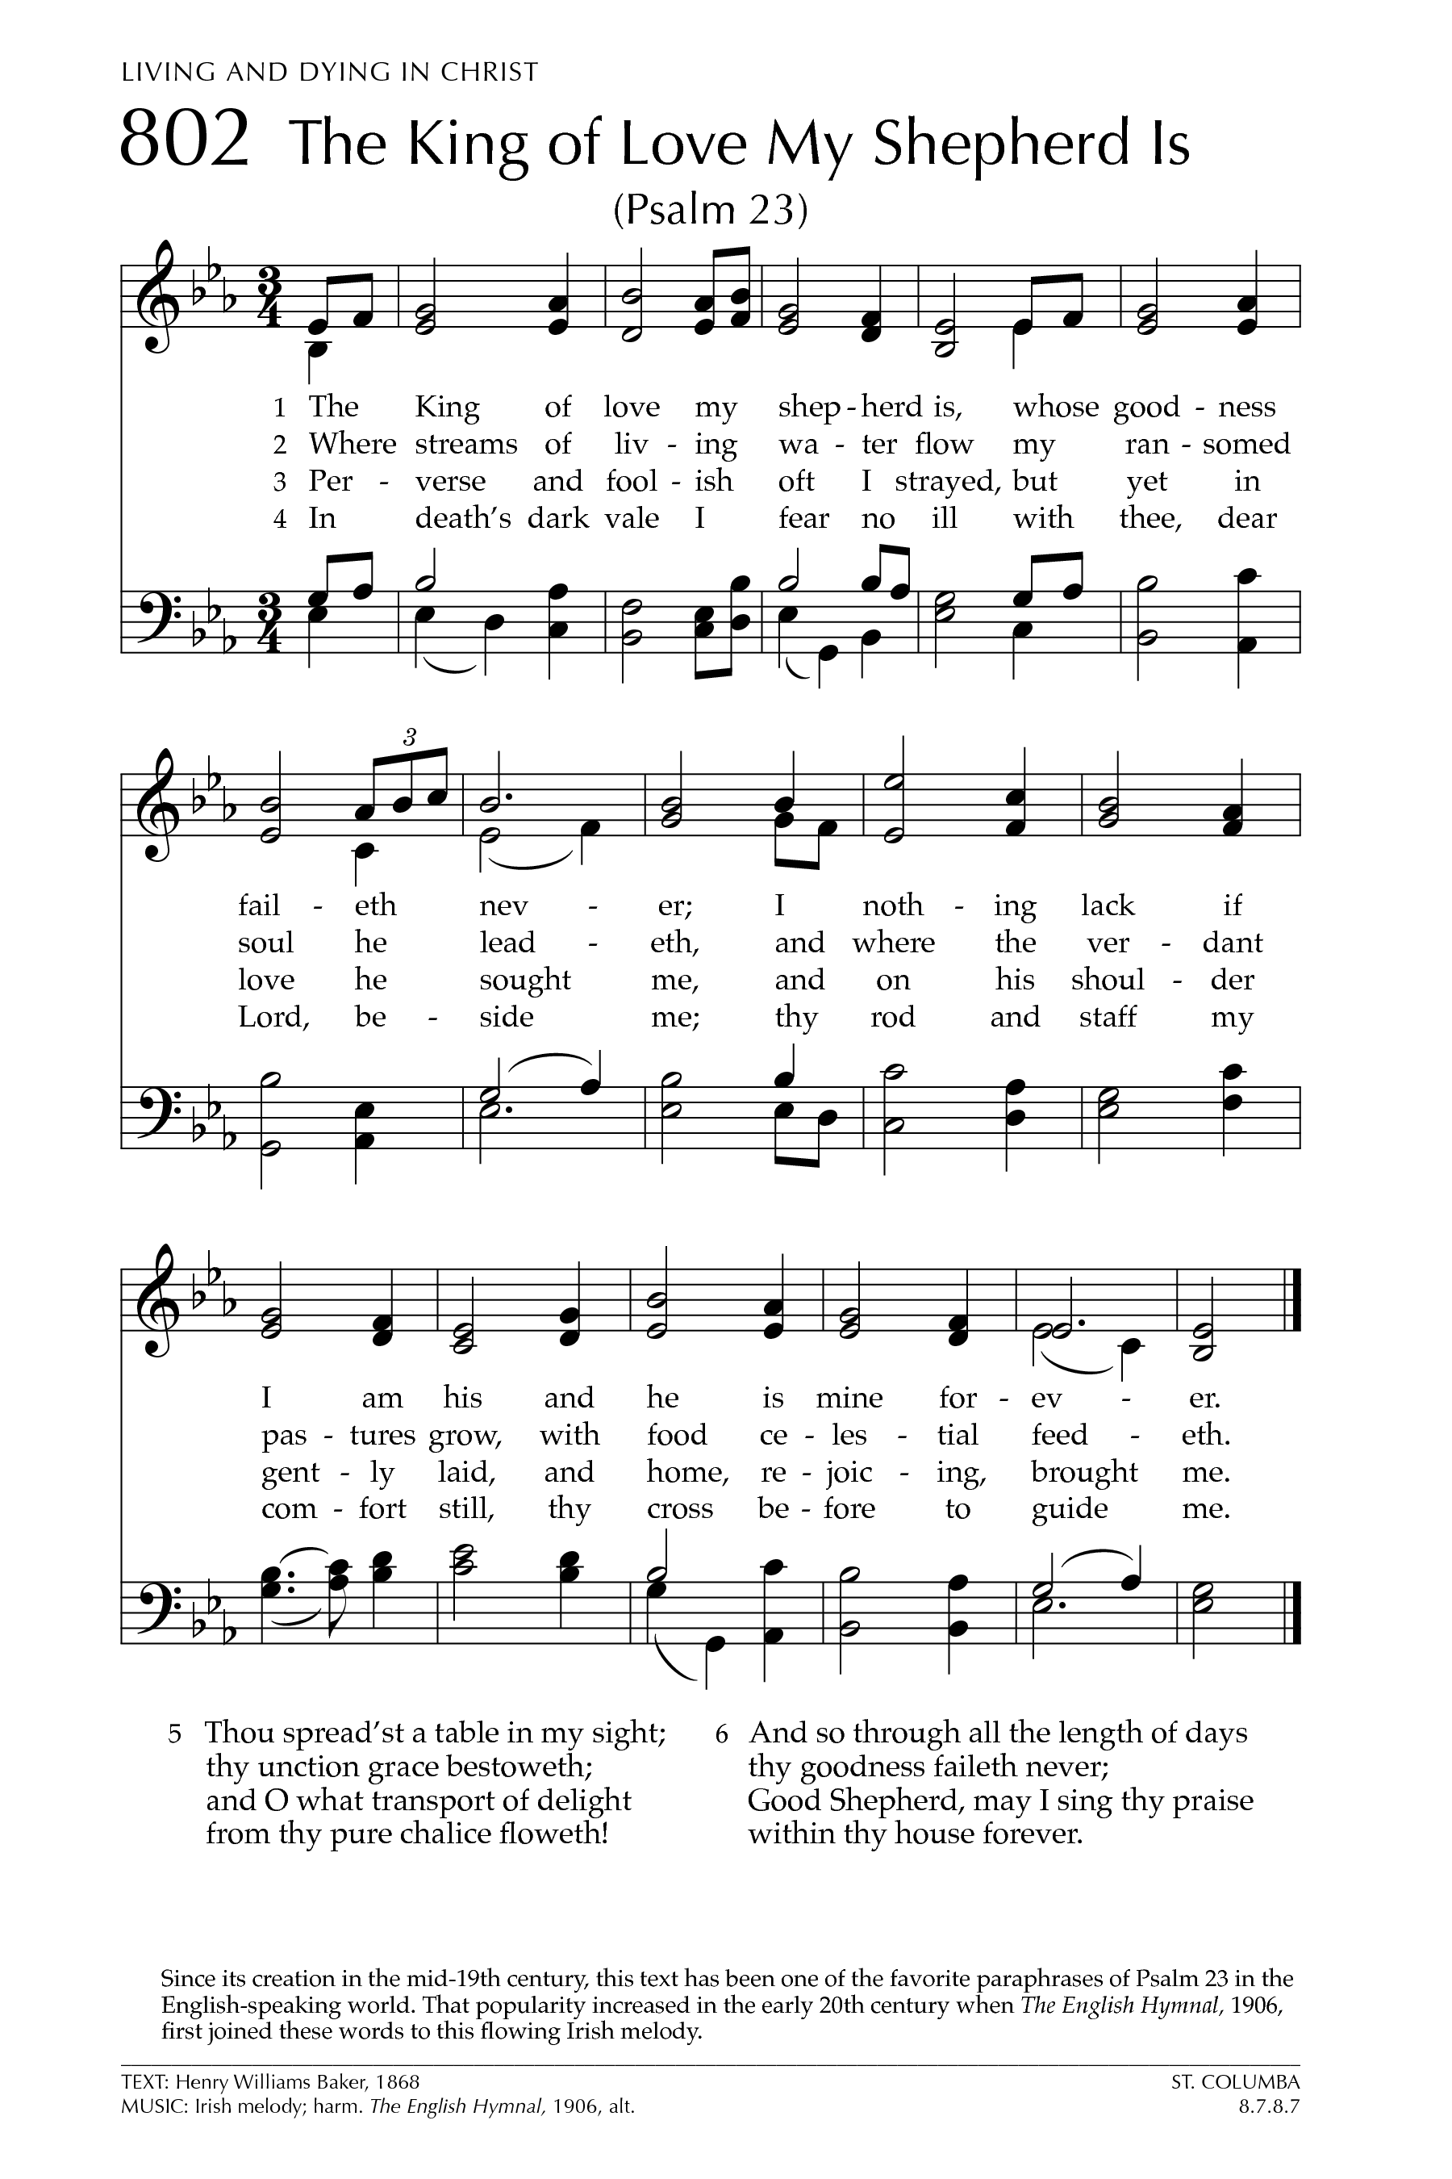

The Order of Service

Prelude: The King of Love My Shepherd Is
(ST. COLUMBA)

Opening Prayer:

Almighty God, ruler of heaven and earth,
crown our worship with your presence,
and reign in every thoughts, words, and worship.
We pray through Christ our King.
Amen.

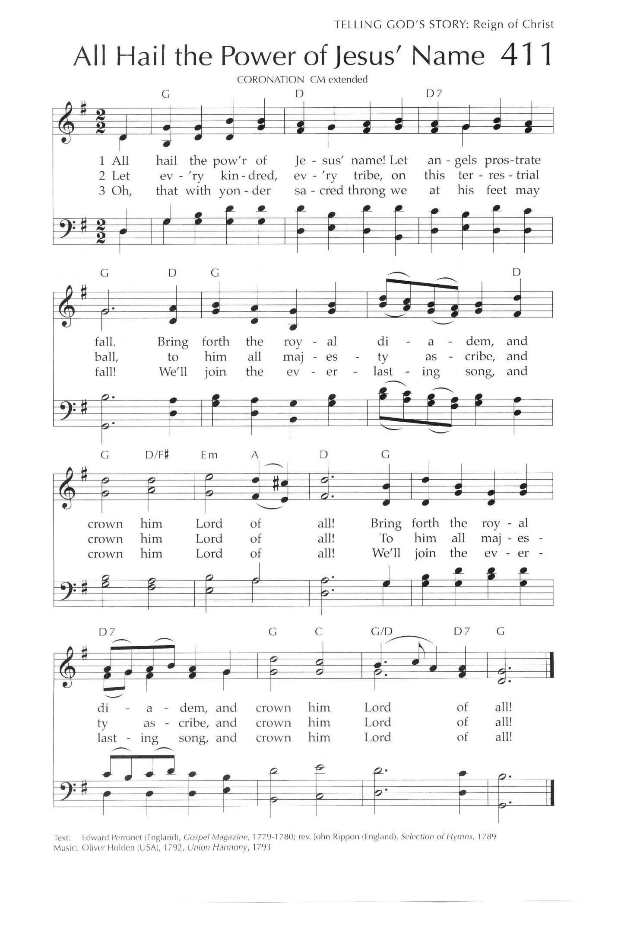
PROCESSIONAL: All Hail the Power of Jesus Name
Words: Edward Peronett; Tune: Coronation

All hail the pow’r of Jesus’ Name!
Let angels prostrate fall;
Bring forth the royal diadem,
And crown Him Lord of all!
Bring forth the royal diadem,
And crown Him Lord of all!

Ye chosen seed of Israel’s race,
Ye ransomed from the fall,
Hail Him Who saves you by His grace,
And crown Him Lord of all!
Hail Him Who saves you by His grace,
And crown Him Lord of all!

Let every kindred, every tribe,
On this terrestrial ball,
To Him all majesty ascribe,
And crown him, Lord of all!
To Him all majesty ascribe,
And crown him, Lord of all!

Oh, that with yonder sacred throng
We at His feet may fall!
We’ll join the everlasting song,
And crown him, Lord of all!
We’ll join the everlasting song,
And crown him, Lord of all!

WELCOME: Fr. Kenute

GREETING:

The grace of our Lord Jesus Christ, and the love of God
and the fellowship of the Holy Spirit, be with you all.
And also with you.

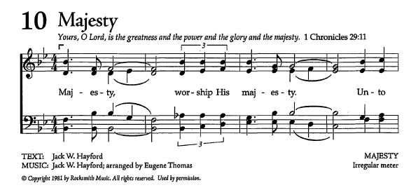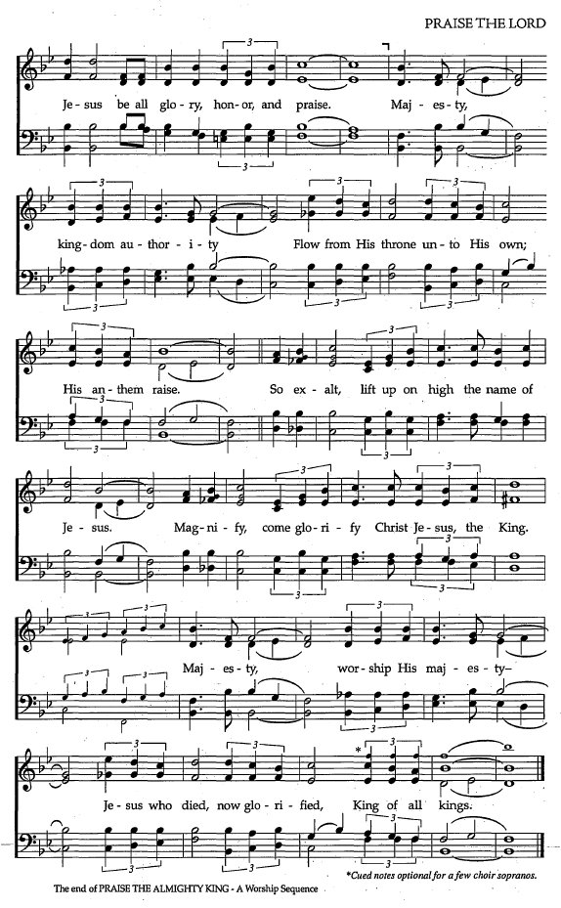
THE COLLECT FOR PURITY:

Almighty God,
to you all hearts are open, all desires known, and from you no secrets are hidden.
Cleanse the thoughts of our hearts by the inspiration of your Holy Spirit,
that we may perfectly love you, and worthily magnify your holy name;
through Christ our Lord. Amen.

Children/Youth Talk: Canon Abbah

INTROIT: Majesty
Text: Jack W. Hayford

Majesty, worship His Majesty
Unto Jesus be glory honour and praise
Majesty, Kingdom, Authority
Flows from His throne Unto His own
His anthem raise

So exalt, lift upon high
The Name Of Jesus
Magnify come glorify
Christ, Jesus the King
Majesty, Worship His Majesty
Jesus who died, now glorified
King of all kings.

Jesus who died, now glorified
King of all kings.

THE COLLECT OF THE DAY
Almighty and everlasting God,
whose will it is to restore all things in your well-beloved Son,
our Lord and King, grant that the peoples of the earth,
now divided and enslaved by sin,
may be freed and brought together under his gentle and loving rule;
who lives and reigns with you and the Holy Spirit, one God, now and forever.
Amen.

THE PROCLAMATION OF THE WORD

THE FIRST READING: Jeremiah 23:1-6 (Joan Tait)

A reading from the Book of the Prophet Jeremiah

Woe to the shepherds who destroy and scatter the sheep of my pasture!
says the Lord. Therefore thus says the Lord, the God of Israel, concerning the shepherds who shepherd my people: It is you who have scattered my flock, and have driven them away, and you have not attended to them. So I will attend to you for your evil doings, says the Lord. Then I myself will gather the remnant of my flock out of all the lands where I have driven them, and I will bring them back to their fold, and they shall be fruitful and multiply. I will raise up shepherds over them who will shepherd them, and they shall not fear any longer, or be dismayed, nor shall any be missing, says the Lord. The days are surely coming, says the Lord, when I will raise up for David a righteous Branch, and he shall reign as king and deal wisely, and shall execute justice and righteousness in the land. In his days Judah will be saved and Israel will live in safety. And this is the name by which he will be called: “The Lord is our righteousness.”

The word of the Lord.
Thanks be to God
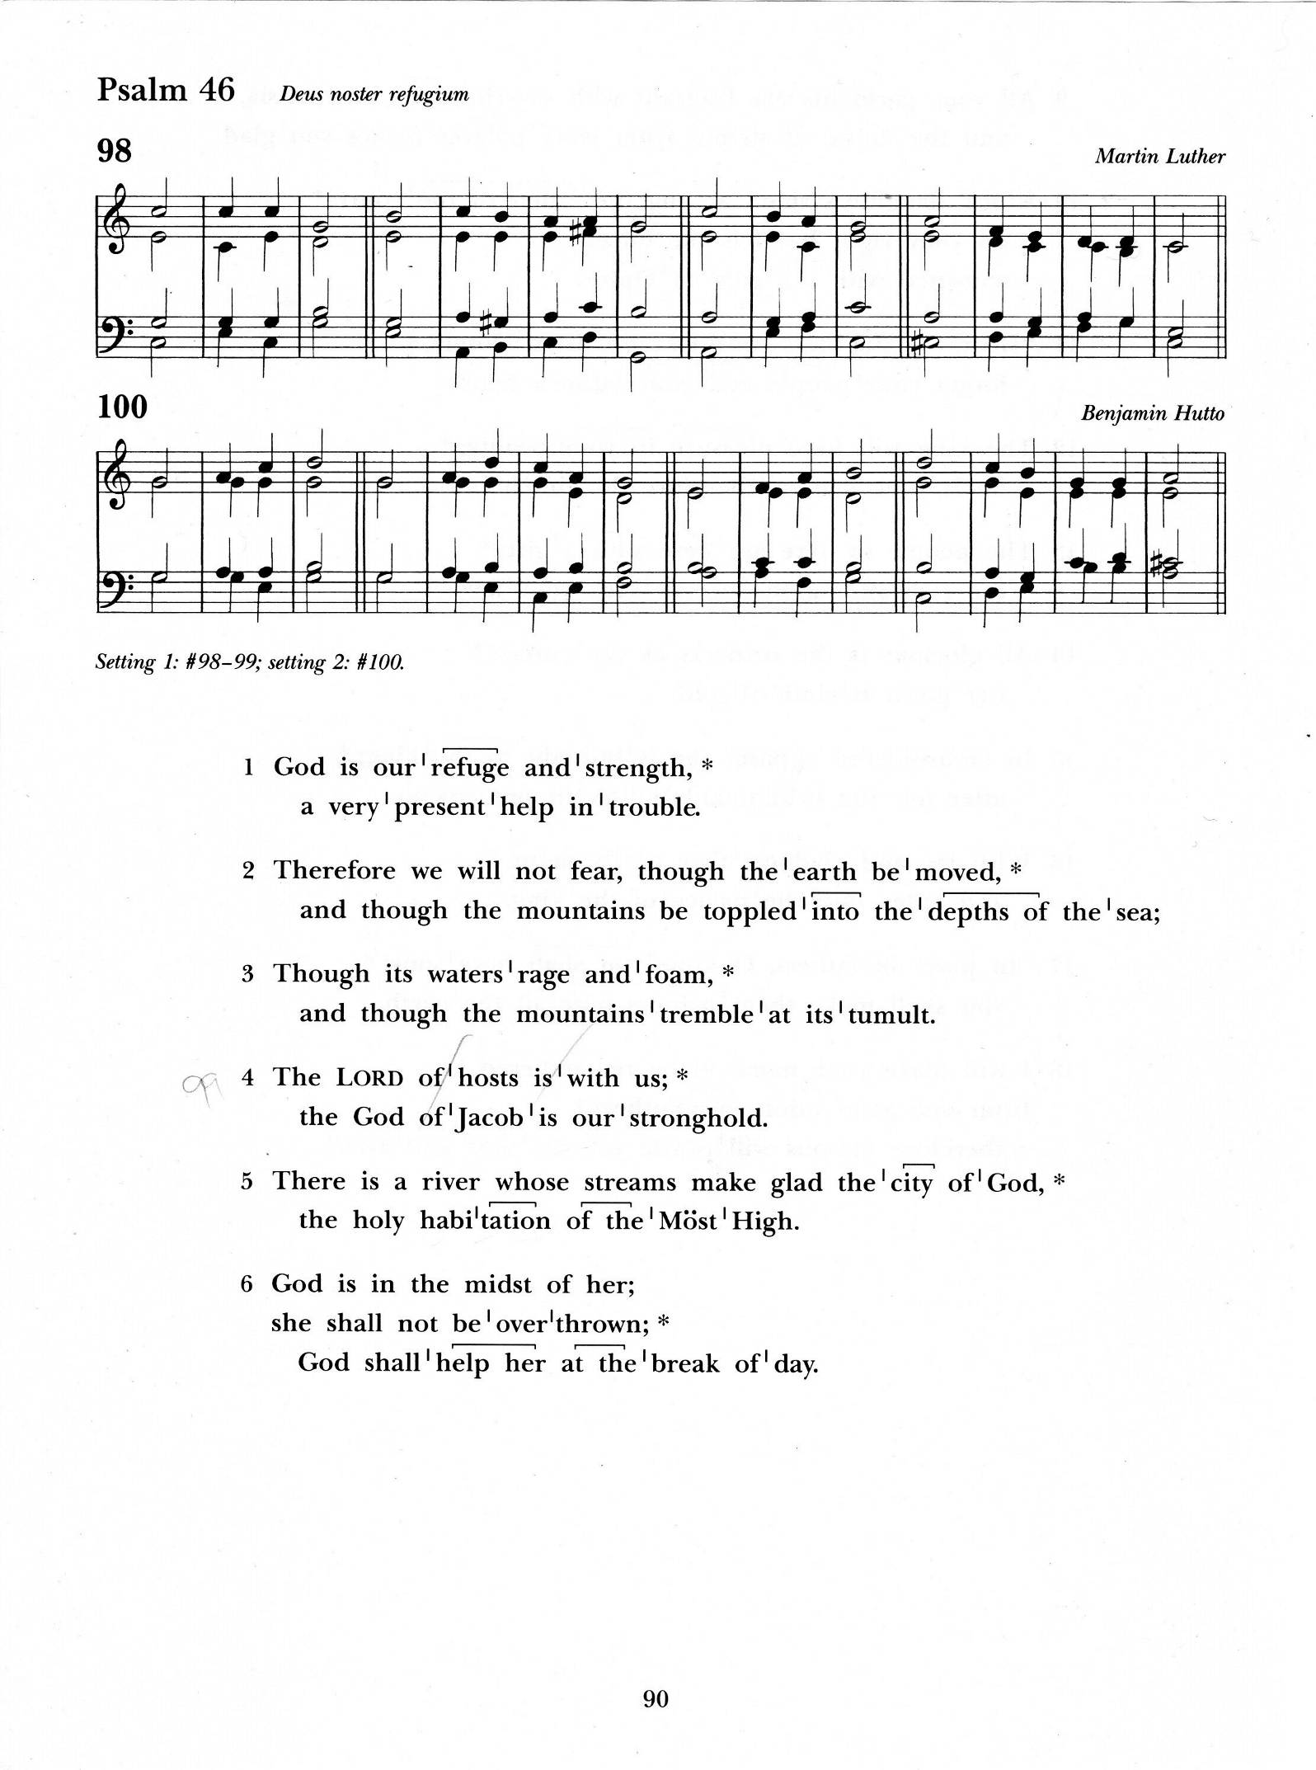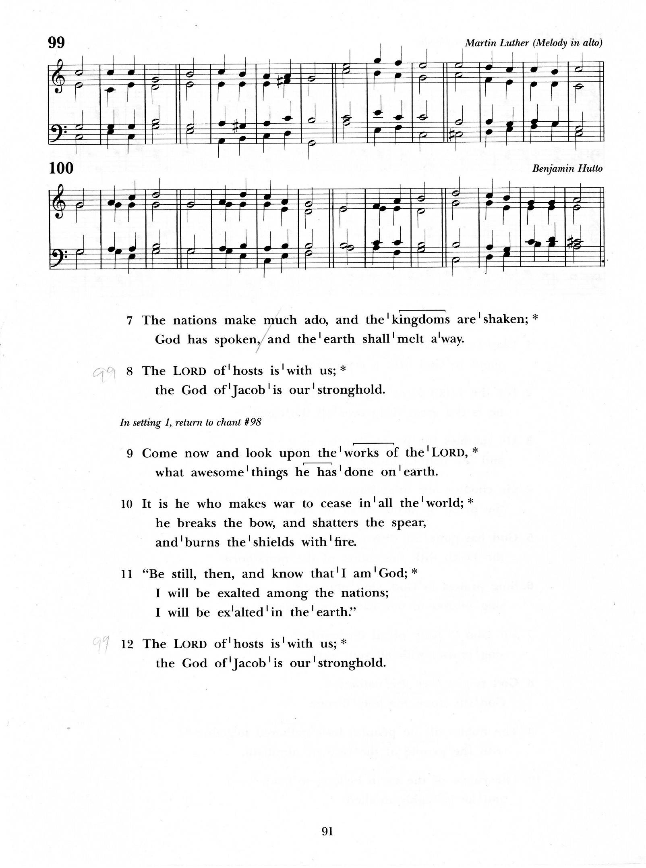
Psalm 46 (chanted)

God is our hope and strength, a very present help in trouble.
Therefore we will not fear, though the earth be moved,
and though the mountains be toppled into the depths of the sea;

Though its waters rage and foam, and though the mountains tremble at its tumult.
The Lord of hosts is with us; the God of Jacob is our stronghold.

There is a river whose streams make glad the city of God,
the holy habitation of the Most High.
God is in the midst of her; she shall not be overthrown;
God shall help her at the break of day.

The nations make much ado, and the kingdoms are shaken;
God has spoken, and the earth shall melt away.
The Lord of hosts is with us;
the God of Jacob is our stronghold.

Come now and look upon the works of the Lord,
what awesome things he has done on earth.
It is he who makes war to cease in all the world;
he breaks the bow, and shatters the spear,
and burns the shields with fire.

“Be still, then, and know that I am God; I will be exalted
among the nations; I will be exalted in the earth.”
The Lord of hosts is with us;
the God of Jacob is our stronghold.

Glory to the Father, and to the Son, and to the Holy Spirit:
As it was in the beginning, is now, and will be for ever. Amen.

THE SECOND READING Colossians 1:11-20 (Jonathan Small)

A Reading from the letter of Paul to the Colossians

May you be made strong with all the strength that comes from his glorious power, and may you be prepared to endure everything with patience, while joyfully
giving thanks to the Father, who has enabled you to share in the inheritance of the saints in the light. He has rescued us from the power of darkness and transferred us into the kingdom of his beloved Son, in whom we have redemption, the forgiveness of sins. He is the image of the invisible God, the firstborn of all creation; for in him all things in heaven and on earth were created, things visible and invisible, whether thrones or dominions or rulers or powers—all things have been created through him and for him. He himself is before all things, and in him all things hold together. He is the head of the body, the church; he is the beginning, the firstborn from the dead, so that he might come to have first place in everything. For in him all the fullness of God was pleased to dwell, and through him God was pleased to reconcile to himself all things, whether on earth or in heaven, by making peace through the blood of his cross.

The word of the Lord
Thanks be to God

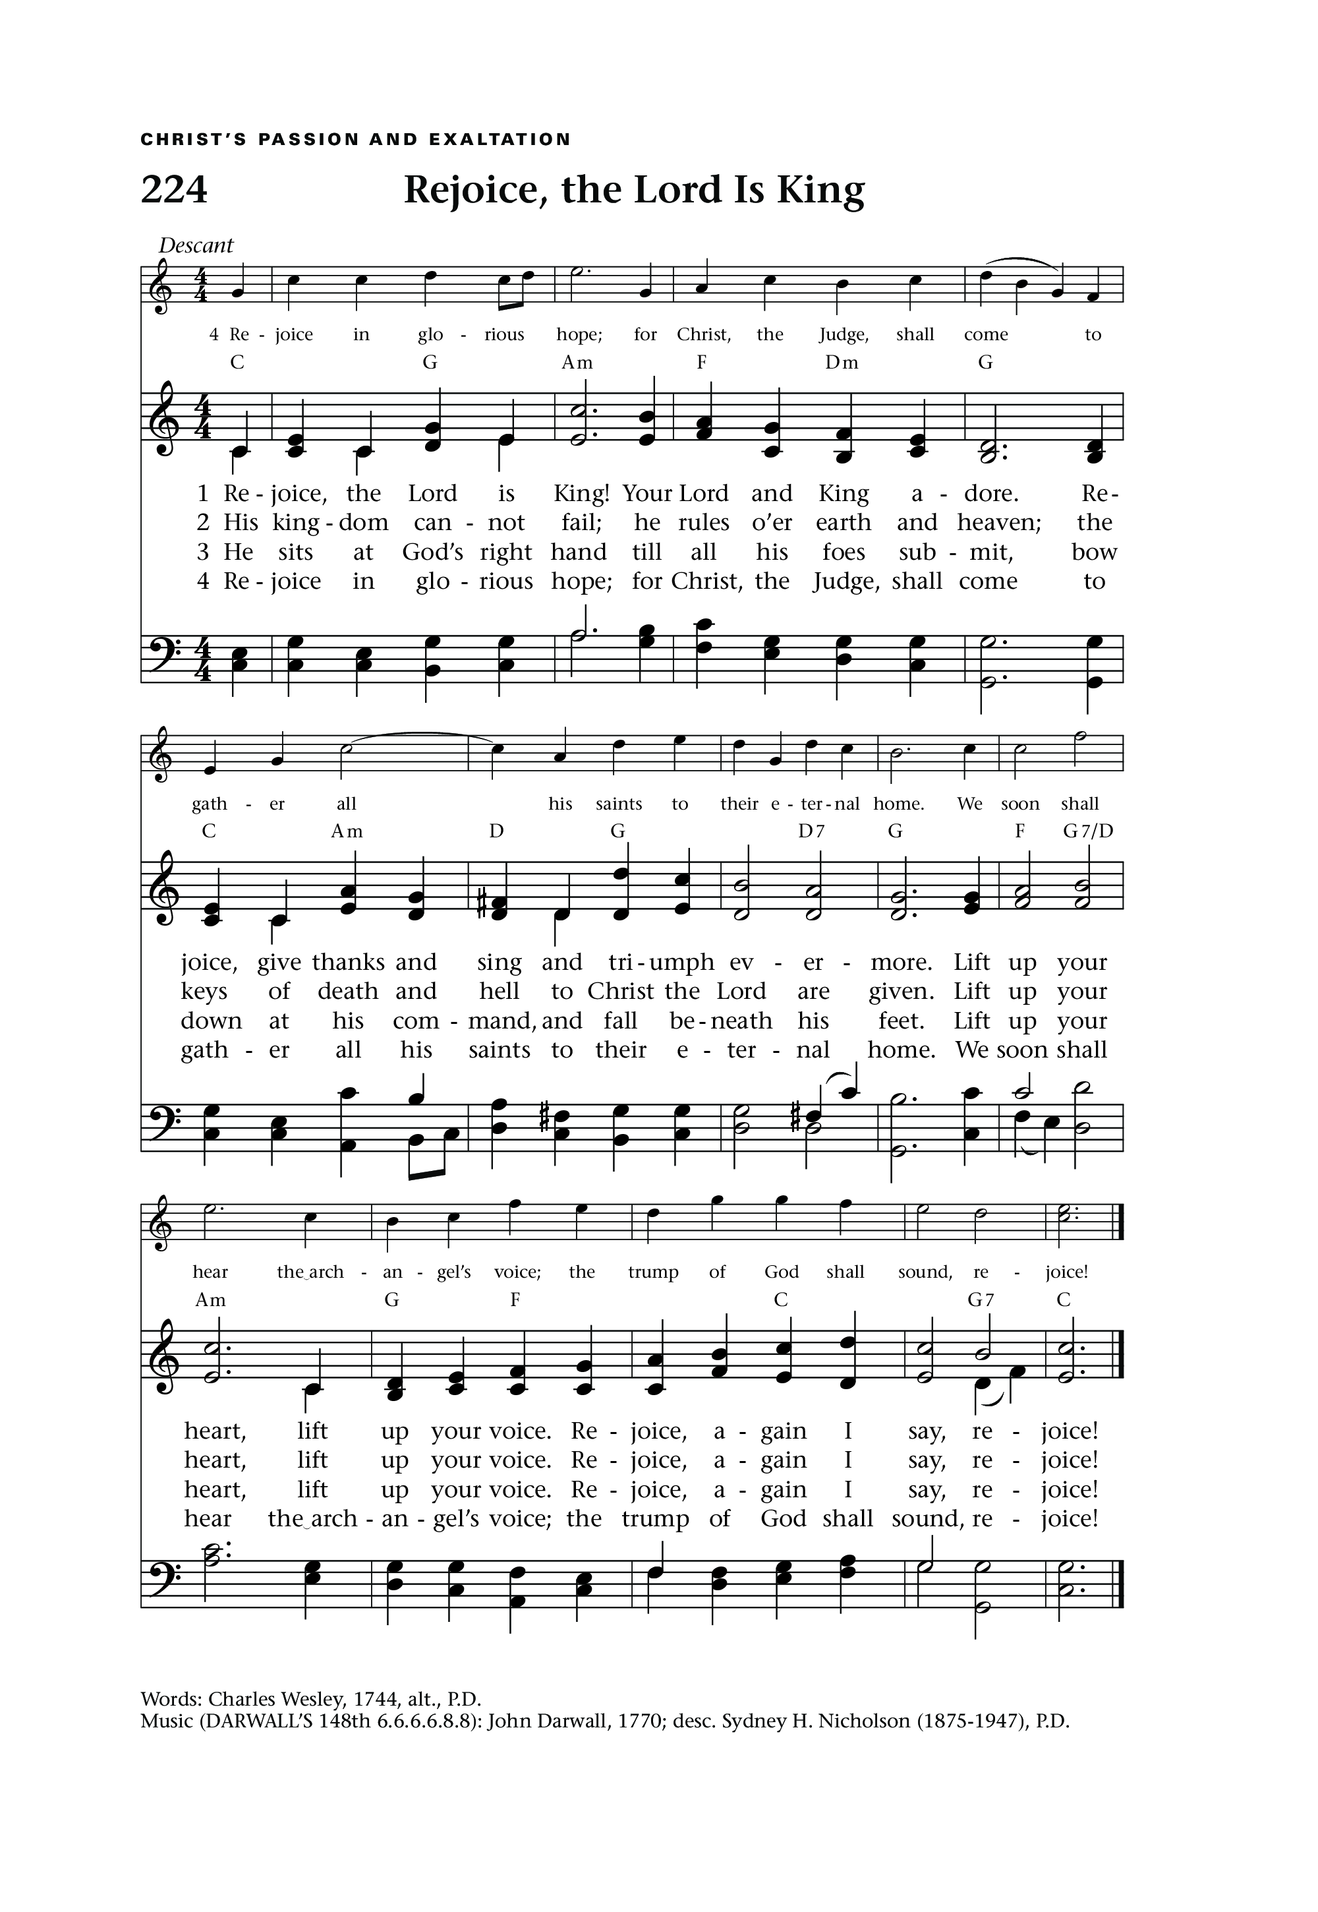
THE GRADUAL: Rejoice the Lord is King
Words: Charles Wesley; Tune: DARWALL

Rejoice, the Lord is King!
Your Lord and King adore;
Rejoice, give thanks, and sing,
And triumph evermore;
Lift up your heart, lift up your voice;
Rejoice, again I say, rejoice!

Jesus, the Saviour, reigns,
The God of truth and love;
When He had purged our stains
He took His seat above;
Lift up your heart, lift up your voice;
Rejoice, again I say, rejoice!

His kingdom cannot fail,
He rules o’er earth and Heav’n,
The keys of death and hell
Are to our Jesus giv’n;
Lift up your heart, lift up your voice;
Rejoice, again I say, rejoice!

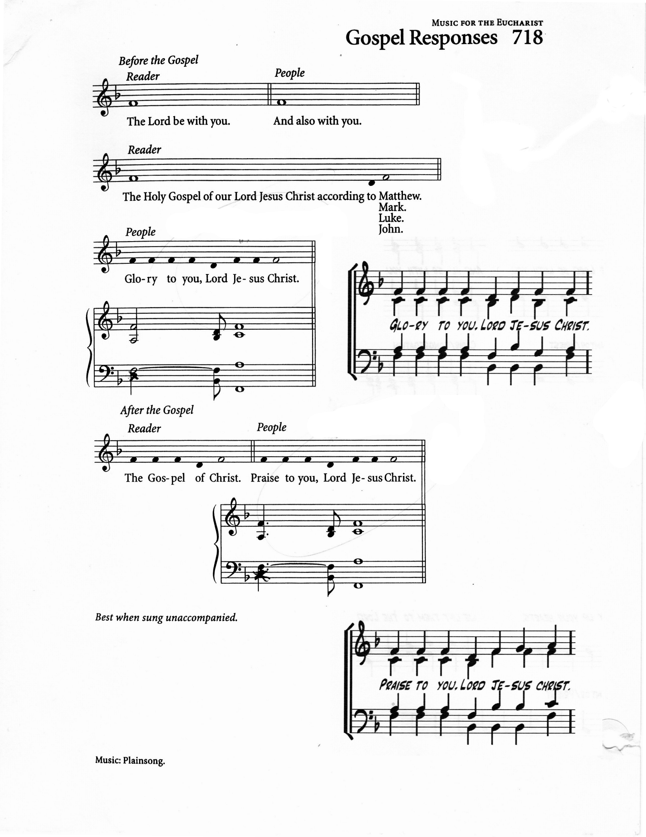
THE HOLY GOSPEL Luke 23:33-43 William Greenidge

The Lord be with you
And also with you

The Holy Gospel of our Lord Jesus Christ according to Luke
Glory to you, Lord Jesus Christ

When they came to the place that is called The Skull, they crucified Jesus there with the criminals, one on his right and one on his left. Then Jesus said, “Father, forgive them; for they do not know what they are doing.” And they cast lots to divide his clothing. And the people stood by, watching; but the leaders scoffed at him, saying, “He saved others; let him save himself if he is the Messiah of God, his chosen one!” The soldiers also mocked him, coming up and offering him sour wine, and saying, “If you are the King of the Jews, save yourself!” There was also an inscription over him, “This is the King of the Jews.” One of the criminals who were hanged there kept deriding him and saying, “Are you not the Messiah? Save yourself and us!”
But the other rebuked him, saying, “Do you not fear God, since you are under the same sentence of condemnation? And we indeed have been condemned justly,
for we are getting what we deserve for our deeds, but this man has done nothing wrong.” Then he said, “Jesus, remember me when you come into your kingdom.” He replied, “Truly I tell you, today you will be with me in Paradise.”

The Gospel of Christ
Praise to you, Lord Jesus Christ

THE SERMON Canon Abbah

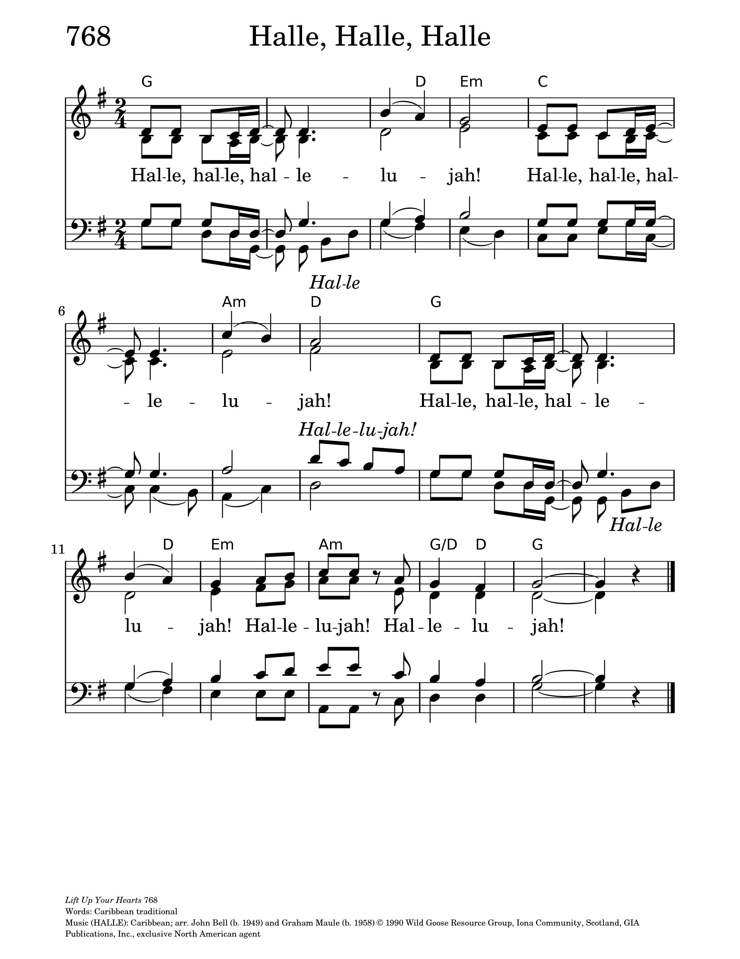
THE APOSTLES’ CREED:

Let us confess the faith of our baptism, as we say,

I believe in God, the Father almighty,
creator of heaven and earth.
I believe in Jesus Christ, his only Son, our Lord.
He was conceived by the power of the Holy Spirit
and born of the Virgin Mary.
He suffered under Pontius Pilate,
was crucified, died, and was buried.
He descended to the dead.
On the third day he rose again.
He ascended into heaven,
and is seated at the right hand of the Father.
He will come again to judge the living and the dead.

I believe in the Holy Spirit,
the holy catholic Church,
the communion of saints,
the forgiveness of sins,
the resurrection of the body,
and the life everlasting. Amen.

A Litany for Healing (Neville Lowe)
Let us pray
Christ Jesus, you are King of kings and Lord of lords,
yet your crown was of thorns and your throne was a cross.
You reign not by force, but by love.
Come, rule in our hearts and heal your world.
Christ our King,
heal us and make us whole.

For those whose bodies are in pain, whose strength is failing,
and whose lives are shadowed by illness—
bring your healing presence and renew their hope.
Christ our King,
heal us and make us whole.

For minds weighed down by anxiety or grief,
for those who live with depression, confusion, or fear—
restore calm and confidence through your Spirit of peace.
Christ our King,
heal us and make us whole.

For hearts broken by loss,
for families and communities torn by division or conflict—
bind up the wounds of your people and reconcile us in your love.
Christ our King,
heal us and make us whole.

For nations at war,
for places where greed and power crush the weak,
and for all who suffer injustice—establish your reign of mercy, truth, and peace.
Christ our King,
heal us and make us whole.

For your Church, called to be a sign of your kingdom—
forgive our pride, renew our compassion,
and unite us in your mission to heal and bless the world.
Christ our King,
heal us and make us whole.

For ourselves, Lord Jesus—
when faith falters and love grows cold, reign in us again,
that your kingdom may come in our hearts and homes.
Christ our King,
heal us and make us whole.

Eternal King,
you have conquered sin and death and hold the world in your wounded hands.
Bring healing to every broken life,
and let all creation proclaim your glory,
until the day your reign is complete.
Come, Lord Jesus,
reign in us forever. Amen.

THE CONFESSION AND ABSOLUTION

Dear friends in Christ, God is steadfast in love and infinite in mercy;
he welcomes sinners and invites them to his table.
Let us confess our sins, confident in God's forgiveness.

Most merciful God,
we confess that we have sinned against you in thought, word and deed,
by what we have done and by what we have left undone.
We have not loved you with our whole heart; we have not loved our neighbours as ourselves. We are truly sorry and we humbly repent.
For the sake of your Son Jesus Christ, have mercy on us and forgive us, that we may delight in your will, and walk in your ways, to the glory of your name.
Amen.

Almighty God have mercy upon you, pardon and deliver you from
all your sins, confirm and strengthen you in all goodness,
and keep you in eternal life; through Jesus Christ our Lord.
Amen.
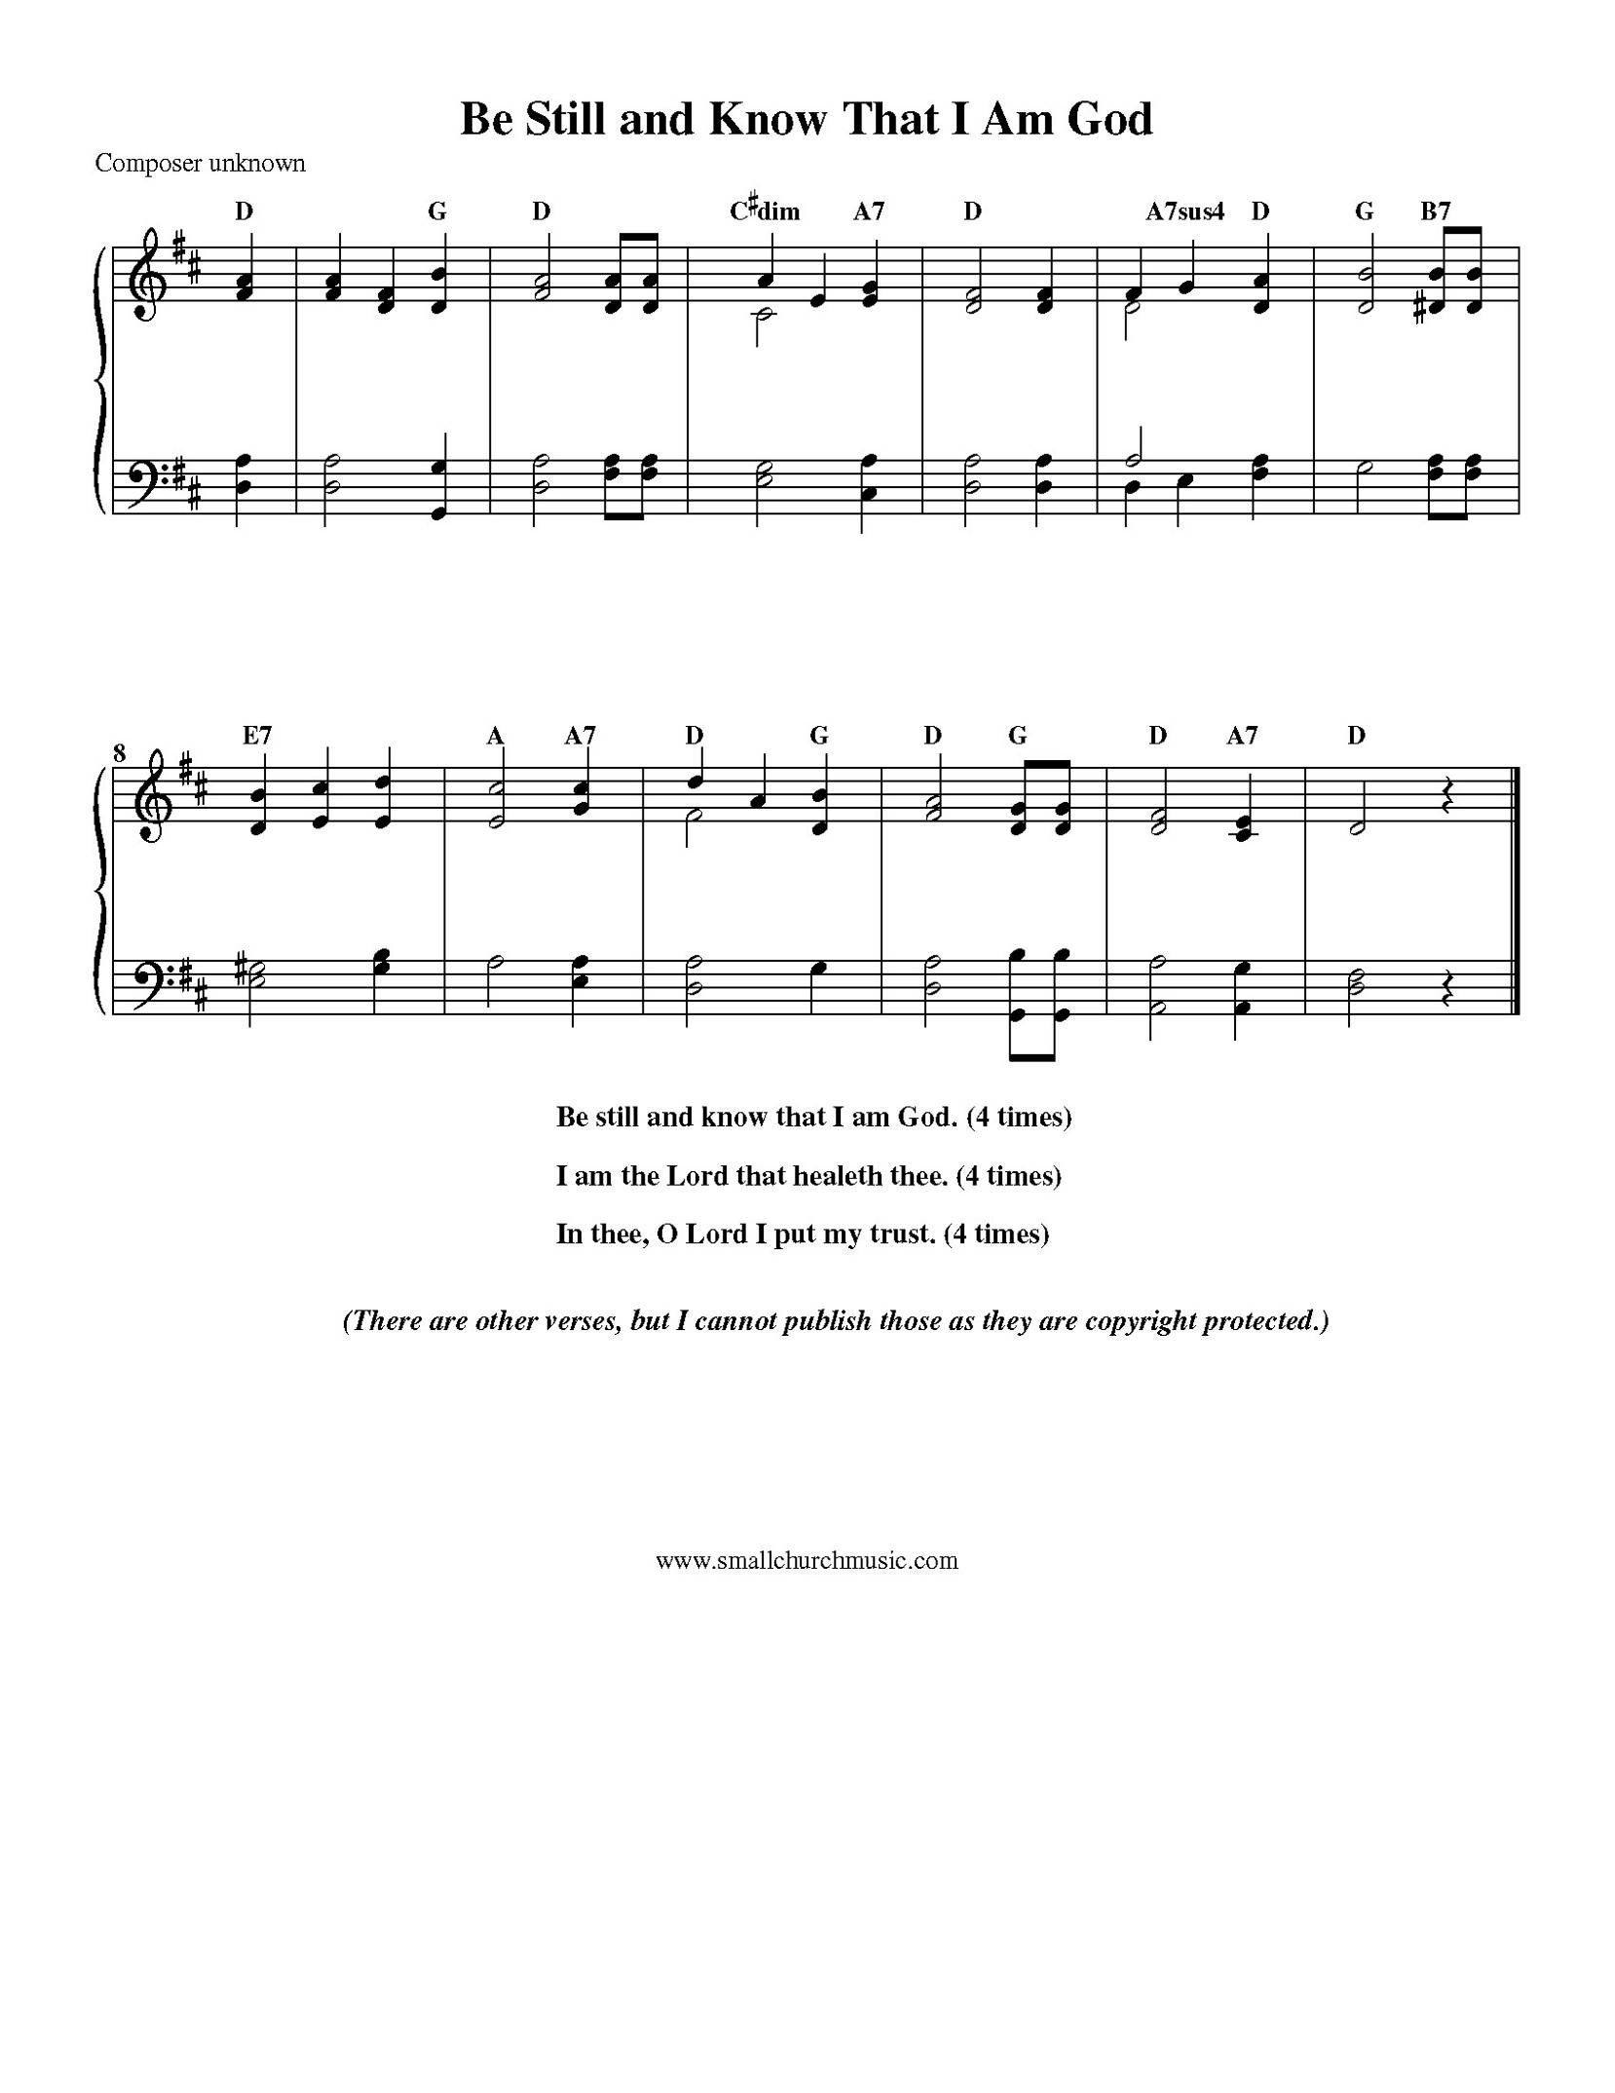
Hymns During the Anointing

Be Still and Know That I Am God
Lyrics: Anonymous; Tune: Be still and Know

Be still and know that I am God
Be still and know that I am God
Be still and know that I am God

I am the Lord that healeth thee
I am the Lord that healeth thee
I am the Lord that healeth thee

In thee, O Lord, I put my trust
In thee, O Lord, I put my trust
In thee, O Lord, I put my trust

How Great Thou Art
Text: Stuart K. Hine; Tune: O STORE GUD

O Lord my God, when I in awesome wonder
Consider all the worlds thy hands have made,
I see the stars, I hear the rolling thunder,
Thy power throughout the universe displayed:

(refrain)
Then sings my soul, my Saviour God, to thee:
How great thou art! How great thou art!
Then sings my soul, my Saviour God, to thee:
How great thou art! How great thou art!

And when I think that God, his Son not sparing,
Sent him to die, I scarce can take it in,
That on the cross, my burden gladly bearing,
He bled and died to take away my sin. (refrain)

When Christ shall come with shout of acclamation
And take me home, what joy shall fill my heart!
Then I shall bow in humble adoration,
And there proclaim, “My God, how great thou art!” (refrain)
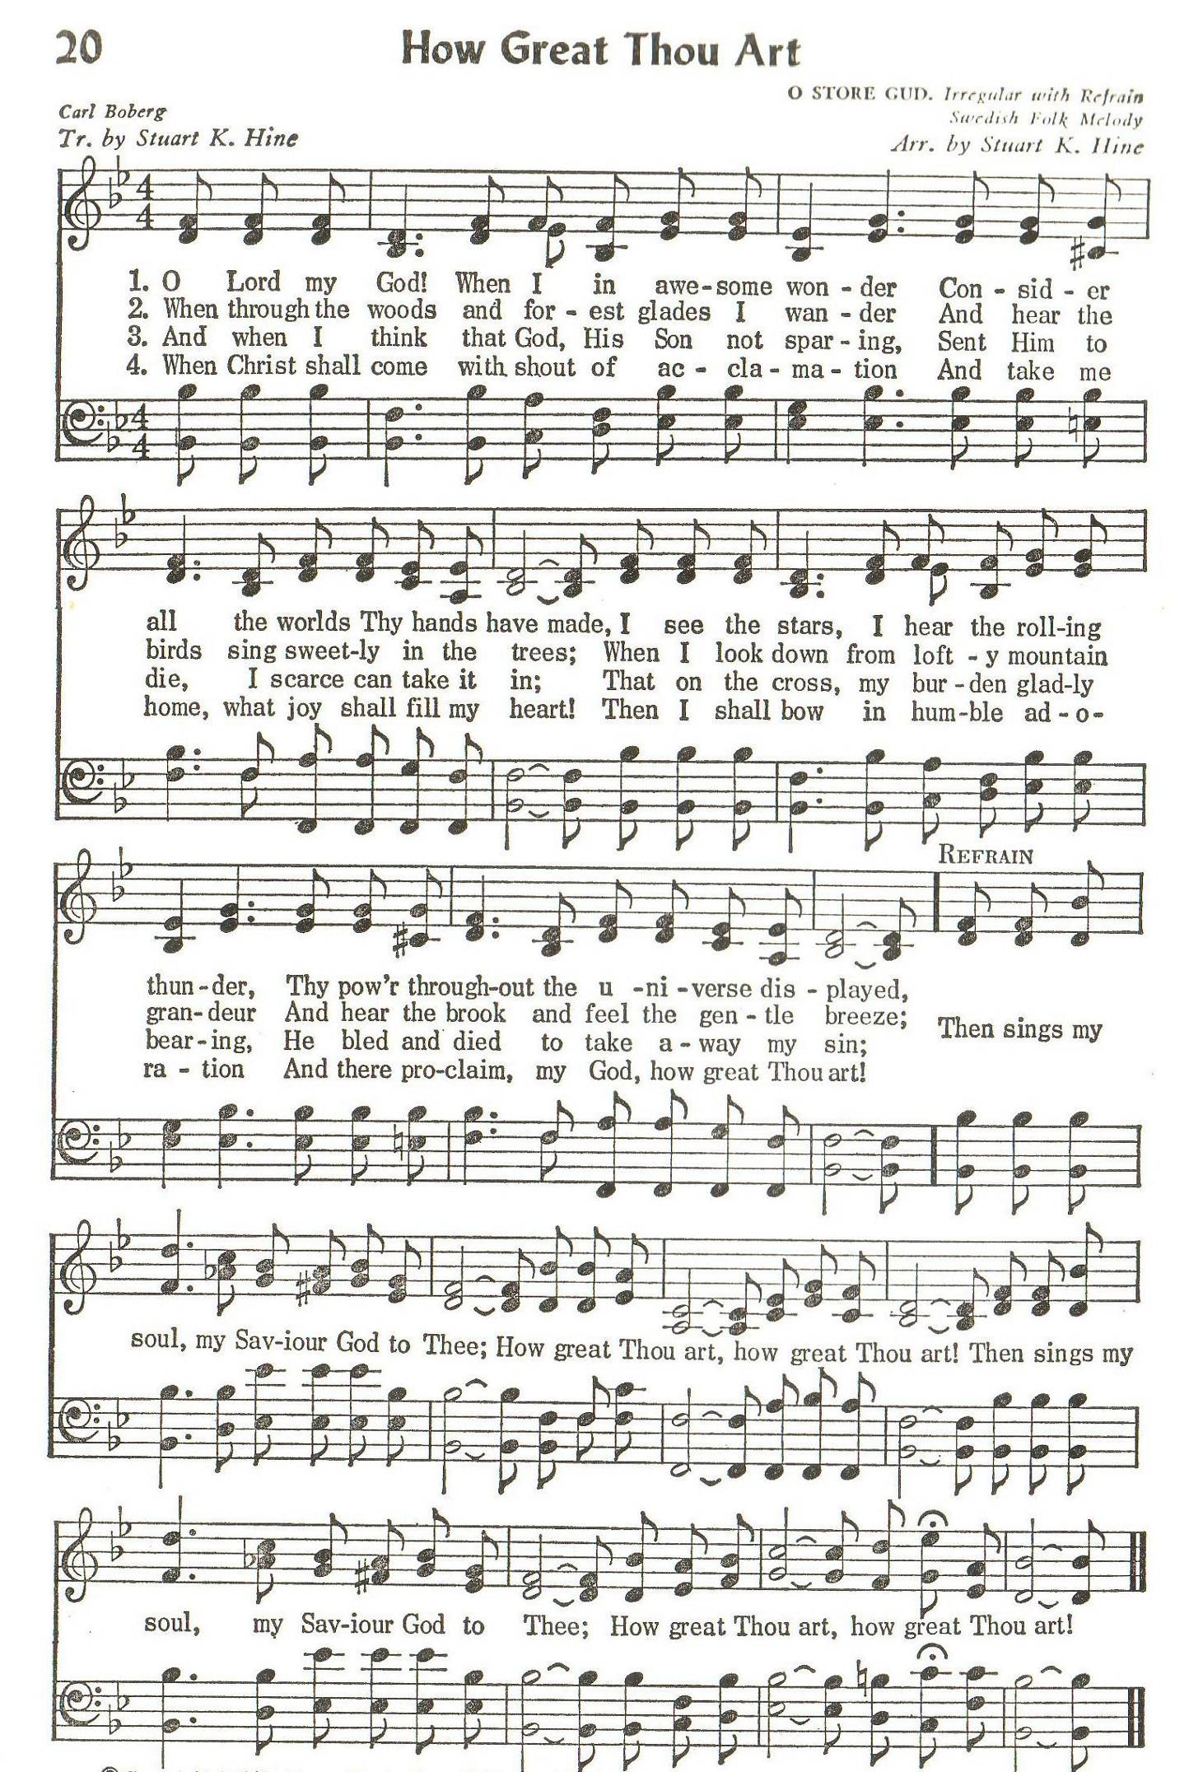
Prayer after the Anointing

The almighty Lord, who is a strong tower for all who put their trust in him,
whom all things in heaven, on earth, and under the earth obey,
be now and evermore your defence. May you believe and trust that the only name under heaven given for health and salvation is the name of our Lord Jesus Christ.
Amen.

The Peace

The peace of the Lord be always with you.
And also with you.

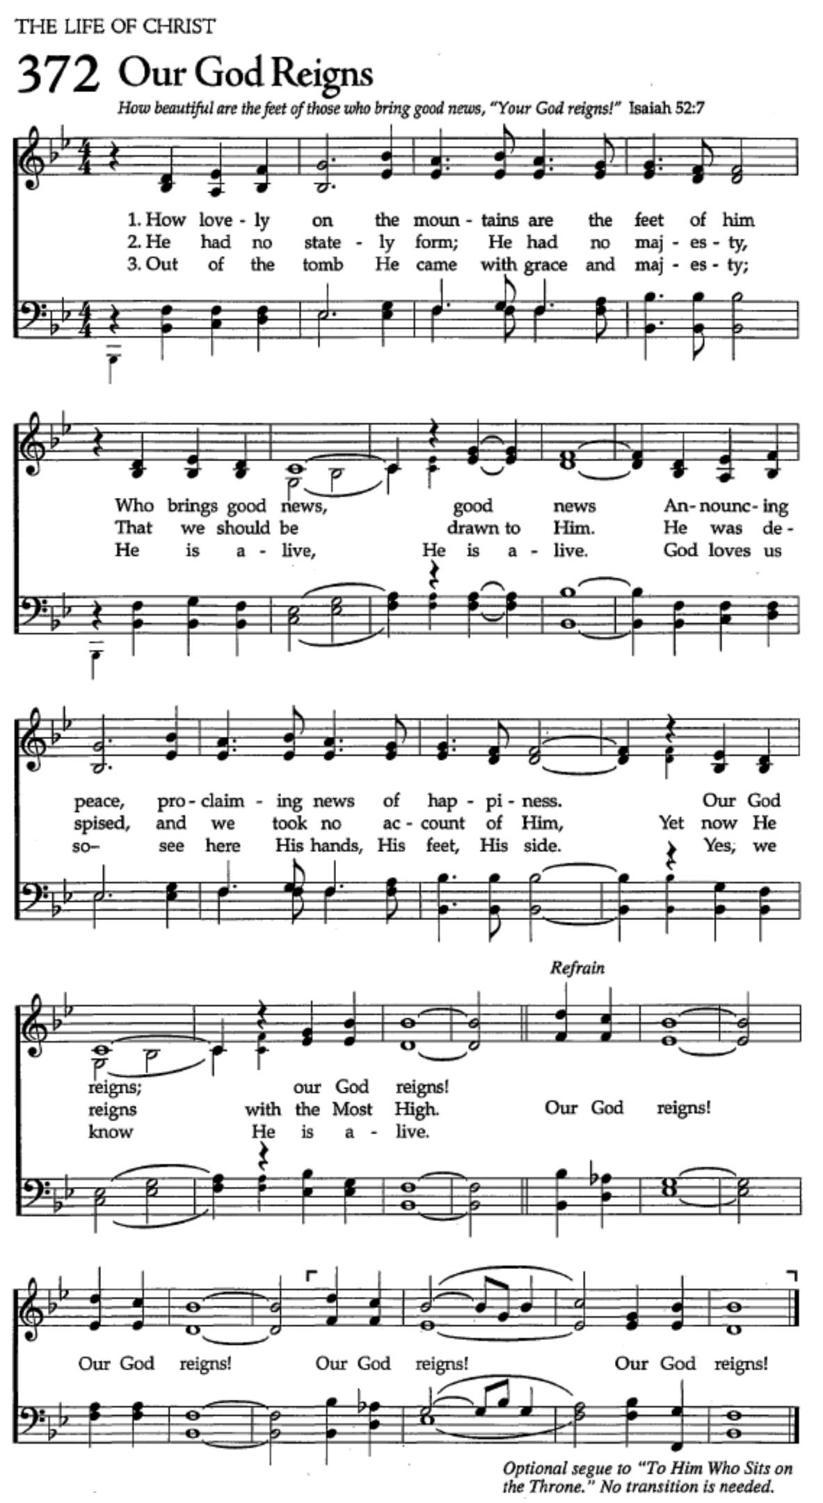
OFFERTORY: Our God Reigns
Text: Leonard E. Smith; Tune: OUR GOD REIGNS

How lovely on the mountains are the feet of him
who brings good news, good news;
Announcing peace, proclaiming news of happiness:
our God reigns, our God reigns!

(refrain)
Our God reigns, our God reigns, our God reigns,
our God reigns, our God reigns!

He had no stately form. He had no majesty
that we should be drawn to him.
He was despised and we took no account of him;
Yet now he reigns with the Most High! (refrain)

Meek as a lamb that's led out to the slaughterhouse,
still as a sheep before its shearer,
His life ran down upon the ground like pouring rain
that we might be born again! (refrain)

Out of the tomb he came with grace and majesty,
he is alive, he is alive!
God loves us so; see here his hands, his feet, his side:
yes, we know he is alive! (refrain)

PRAYER OVER THE GIFTS

Eternal God,
by your grace you have raised us up
and enthroned us with Christ in the heavenly realms.
Receive all we offer you this day
and lead us in those good works for which you have created us.
We ask this in the name of Jesus Christ the Lord. Amen.

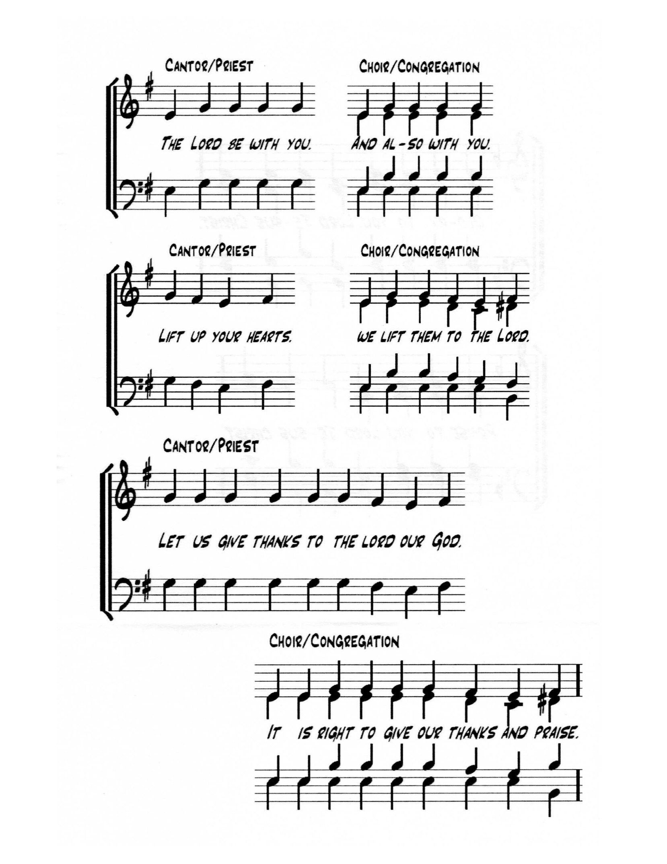
EUCHARISTIC PRAYR 3

The Lord be with you.
And also with you.

Lift up your hearts
We lift them to the Lord

Let us give thanks to the Lord our God.
It is right to give our thanks and praise.

Blessed are you, gracious God, creator of heaven and earth;
we give you thanks and praise through Jesus Christ our Lord.
You exalted him as Lord of all creation that he might present to you
an eternal and universal kingdom: a kingdom of truth and life,
a kingdom of holiness and grace, a kingdom of justice, love, and peace.

Therefore, at the name of Jesus every knee shall bow
as heaven and earth proclaim the glory of your name.
Holy, holy, holy, Lord,
God of power and might,
Heaven and earth are full of your glory.
Hosanna in the highest.
Blessed is he who comes in the name of the Lord.
Hosanna in the highest.

We give thanks to you, Lord our God,
for the goodness and love you have made known to us in creation;
in calling Israel to be your people;
in your Word spoken through the prophets;
and above all in the Word made flesh, Jesus your Son.
For in these last days you sent him to be incarnate from the Virgin Mary,
to be the Saviour and Redeemer of the world.
In him, you have delivered us from evil,
and made us worthy to stand before you.
In him, you have brought us out of error into truth,
out of sin into righteousness, out of death into life.

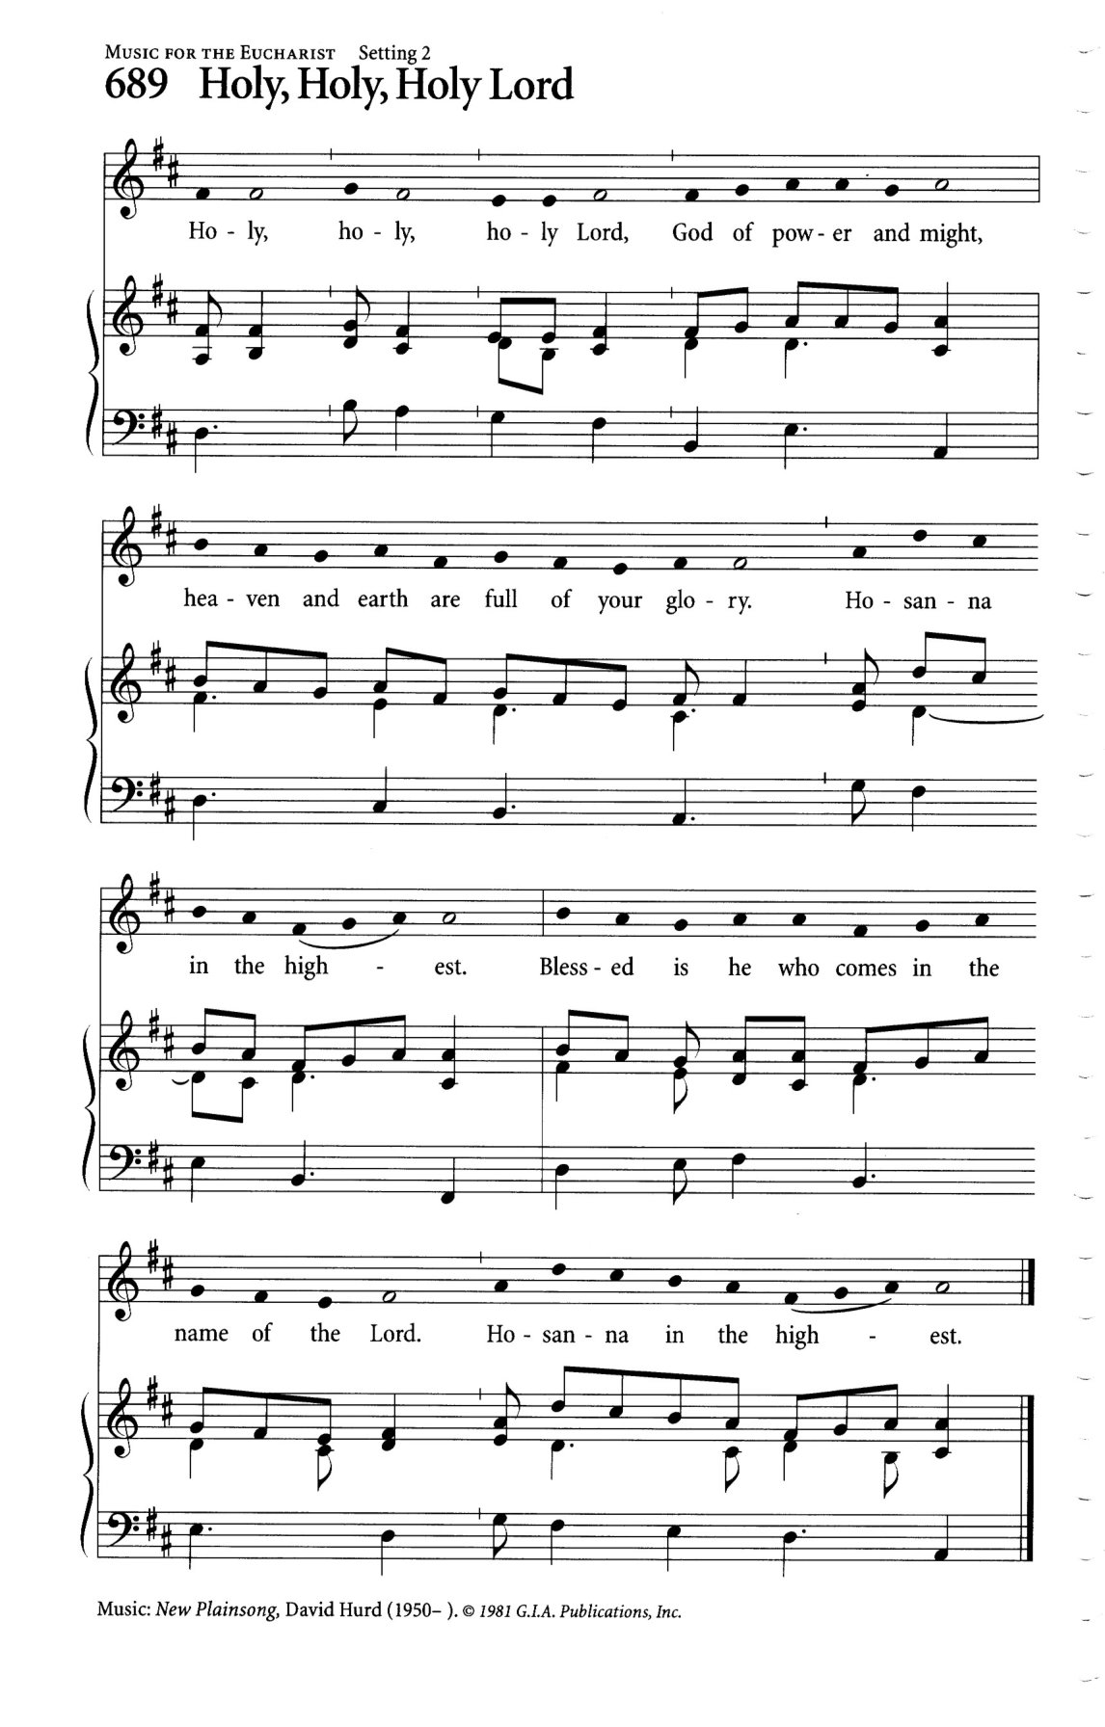
On the night he was handed over to suffering and death,
a death he freely accepted, our Lord Jesus Christ took bread;
and when he had given thanks to you,
he broke it, and gave it to his disciples, and said,
“Take, eat: this is my body which is given for you.
Do this for the remembrance of me.”

After supper he took the cup of wine; and when he had given thanks,
he gave it to them, and said, “Drink this, all of you:
this is my blood of the new covenant,
which is shed for you and for many for the forgiveness of sins.
Whenever you drink it, do this for the remembrance of me.”

Therefore, Father, according to his command,
we remember his death,
we proclaim his resurrection,
we await his coming in glory;

and we offer our sacrifice of praise and thanksgiving to you, Lord of all;
presenting to you, from your creation, this bread and this wine.

We pray you, gracious God, to send your Holy Spirit upon these gifts,
that they may be the sacrament of the body of Christ
and his blood of the new covenant.
Unite us to your Son in his sacrifice, that we, made acceptable in him,
may be sanctified by the Holy Spirit.

In the fullness of time, reconcile all things in Christ,
and make them new, and bring us to that city of light
where you dwell with all your sons and daughters;
through Jesus Christ our Lord, the firstborn of all creation,
the head of the Church, and the author of our salvation;
by whom, and with whom, and in whom, in the unity of the Holy Spirit,
all honour and glory are yours, almighty Father,
now and for ever.
Amen.

THE LORD’S PRAYER (said)

And now, as our Saviour Christ has taught us, we are bold to say

Our Father, which art in heaven,
hallowed be thy Name,
Thy kingdom come, Thy will be done,
on earth as it is in heaven.
Give us this day our daily bread
And forgive us our trespasses,
As we forgive those who trespass against us.
And lead us not into temptation, but deliver us from evil.
For thine is the kingdom, the power, and the glory,
forever and ever. Amen.

THE BREAKING OF THE BREAD

We break this bread to share in the body of Christ.
We, being many, are one body, for we all share in the one bread.

THE INVITATION

The gifts of God for the People of God
Thanks be to God.

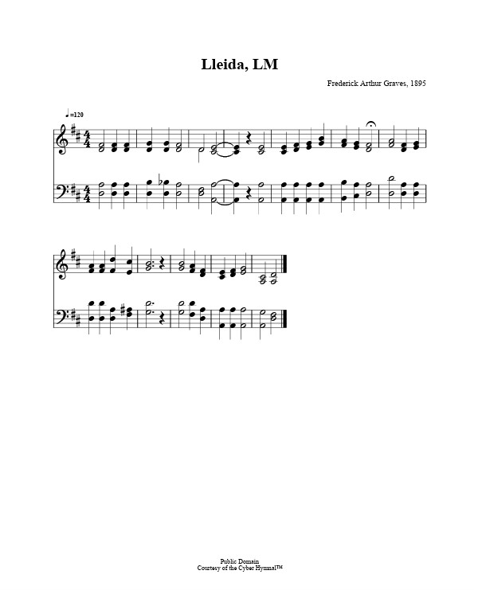
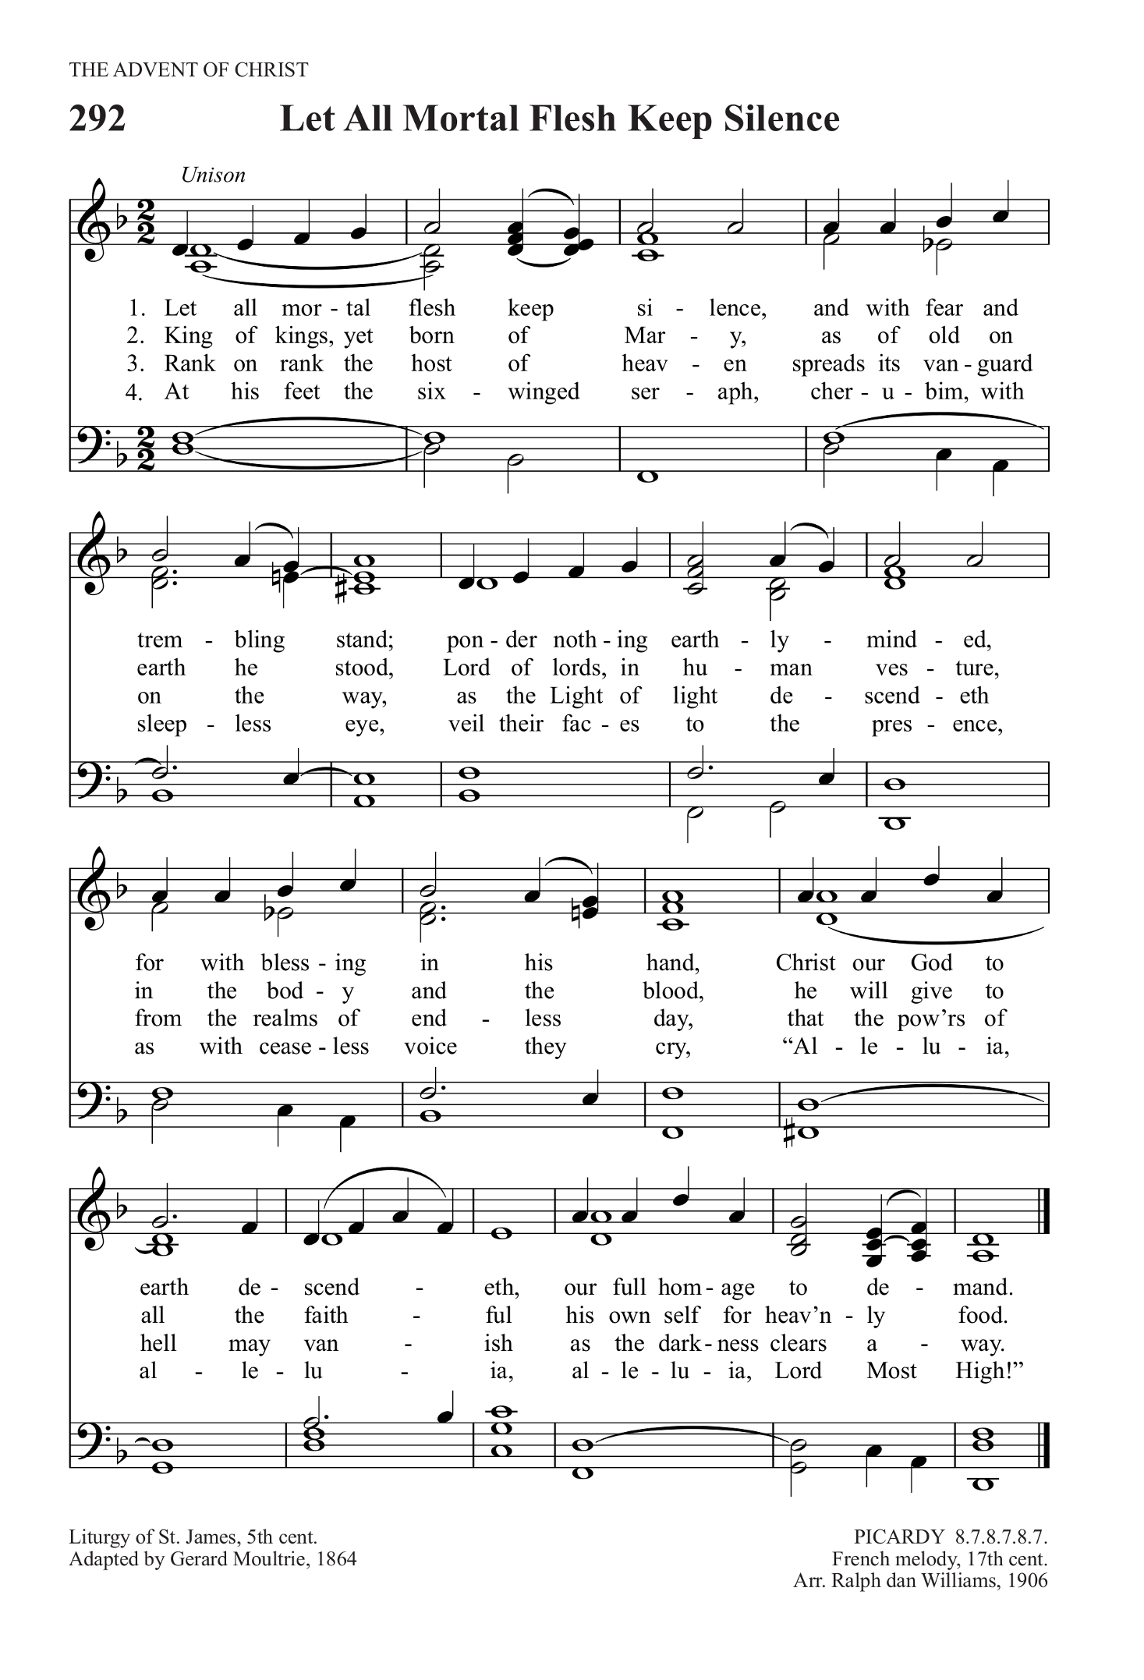
DURING COMMUNION: Let all Mortal Flesh Keep Silence
Text: Gerard Moultrie; Tune: PICARDY

Let all mortal flesh keep silence,
and with fear and trembling stand;
ponder nothing earthly minded,
for, with blessing in His hand,
Christ our God to earth descendeth,
our full homage to demand.

King of kings, yet born of Mary,
as of old on earth He stood,
Lord of lords, in human vesture,
in the body and the blood.
He will give to all the faithful
His own self for heav'nly food.

Rank on rank the host of heaven
spreads its vanguard on the way,
as the Light of light descendeth
from the realms of endless day,
that the pow'rs of hell may vanish
as the darkness clears away.

At His feet the six-winged seraph,
cherubim with sleepless eye,
veil their faces to the Presence,
as with ceaseless voice they cry,
“Alleluia, alleluia,
alleluia, Lord Most High!”

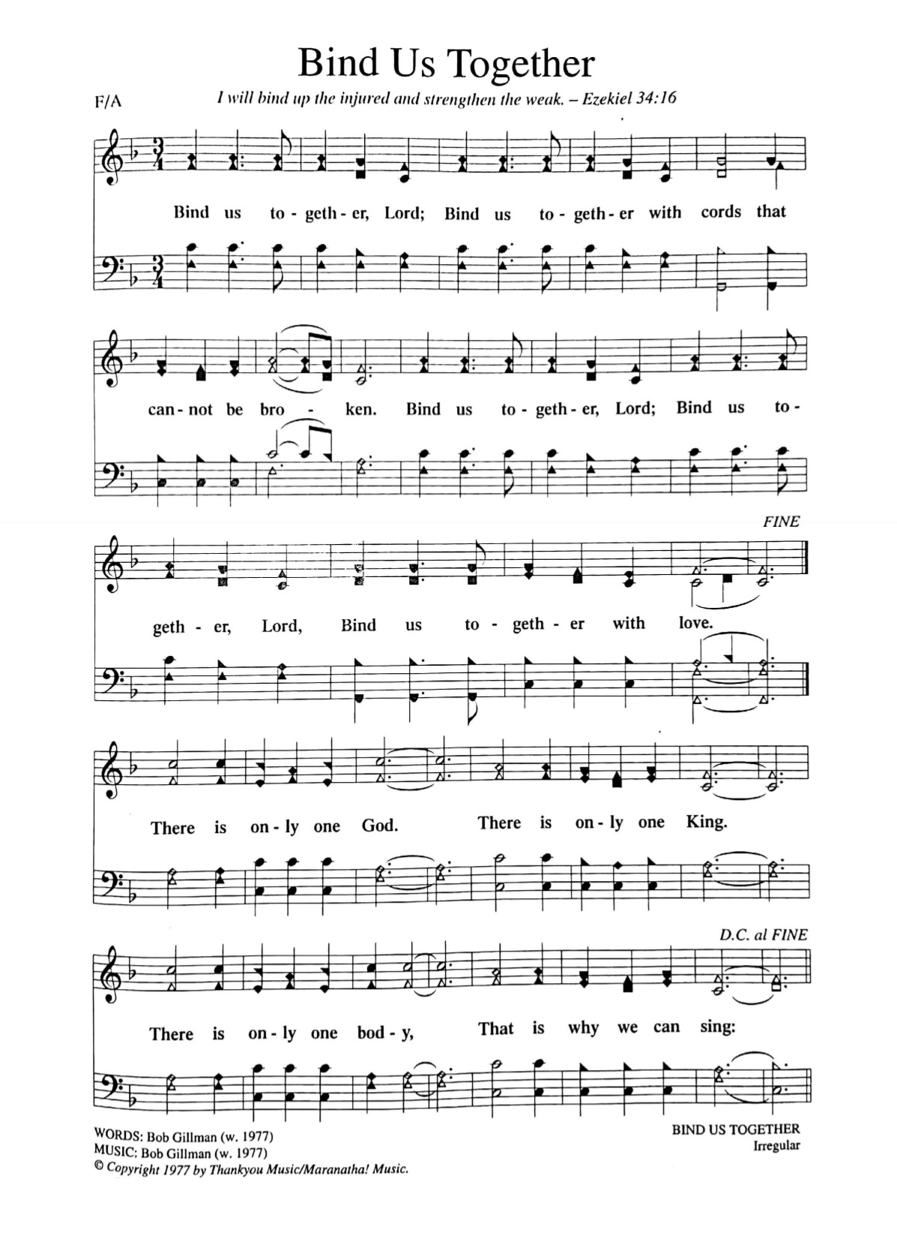
ABLUTIONS: Bind us Together
Text & Music: Bob Gillman

(refrain)
Bind us together, Lord, bind us together,
with cords that cannot be broken.
Bind us together, Lord, bind us together,
bind us together with love.

There is only one God,
there is only one King
there is only one Body
that is why we sing: (refrain)

Made for the glory of God,
purchased by his precious Son,
born with the right to be clean,
for Jesus the victory has won. (refrain)

PRAYER AFTER COMMUNION

Almighty God,
you have made us a royal priesthood
in the kingdom of your Son our Saviour Jesus Christ.
Make known his victory through us, we pray,
that all the world may see his light.
We ask this in the name of Jesus Christ the Lord.
Amen.

THE BLESSING

Christ reigns!
Let his peace rule in your hearts,
his word dwell richly in your lives,
and his joy shine through your witness.
And the blessing of the God almighty,
The Father, the Son, and the Holy Spirit,
be upon you and remain with you always.
Amen.

ANNOUNCEMENTS

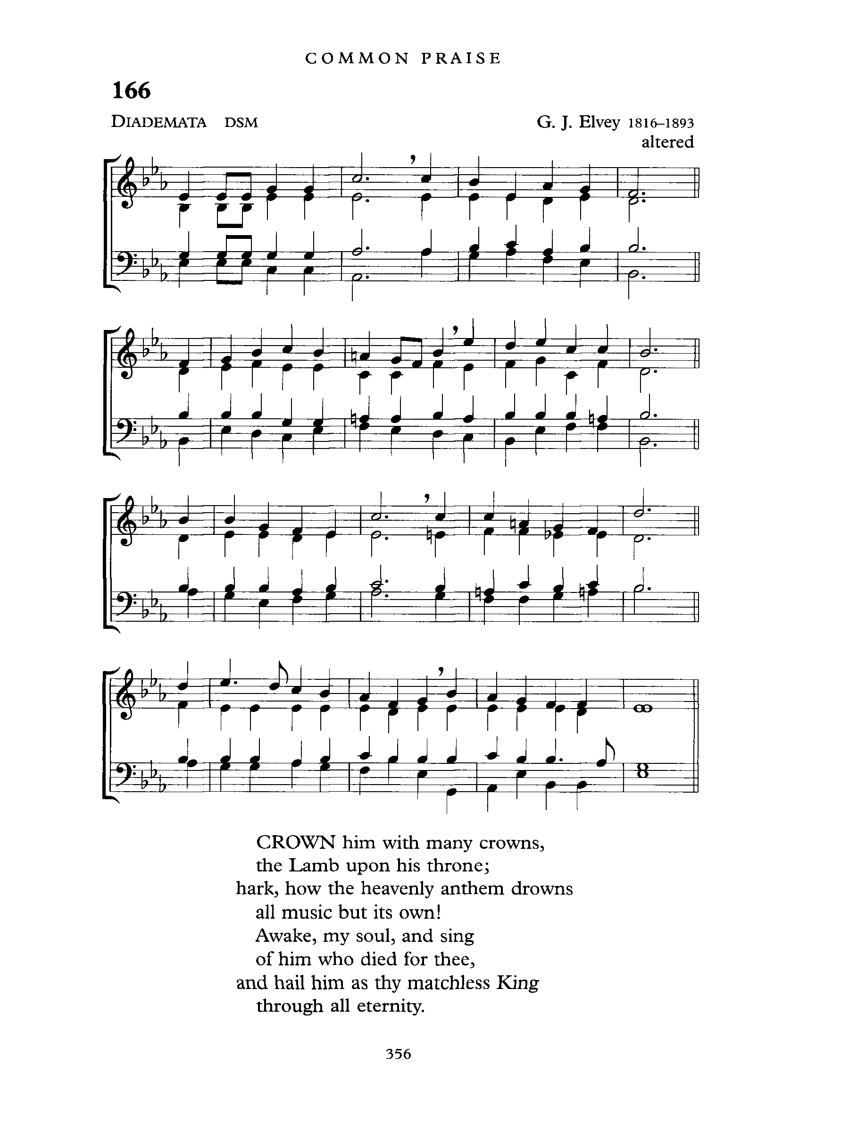
RECESSIONAL: Crown Him With Many Crowns
Words: Matthew Bridges, Tune: DIADEMATA

Crown Him with many crowns,
The Lamb upon His throne;
Hark! How the heav’nly anthem drowns
All music but its own!
Awake, my soul and sing
Of Him Who died for thee,
And hail Him as thy matchless King
Through all eternity.

Crown Him the Lord of love!
Behold His hands and side—
Rich wounds, yet visible above,
In beauty glorified.
No angel in the sky
Can fully bear that sight,
But downward bends His wond’ring eye
At mysteries so bright.

Crown Him the Lord of life!
Who triumphed o’er the grave,
Who rose victorious in the strife
For those He came to save.
His glories now we sing,
Who died, and rose on high,
Who died eternal life to bring,
And lives that death may die.

Crown Him the Lord of heav’n!
One with the Father known,
One with the Spirit through Him giv’n
From yonder glorious throne,
To Thee be endless praise,
For Thou for us hast died;
Be Thou, O Lord, through endless days
Adored and magnified.

THE DISMISSAL

Followers of Christ, Inspired by the Holy Spirit.
Serve the world God loves. Alleluia! Alleluia!
Thanks be to God. Alleluia! Alleluia!

Postlude: Trumpet Tune
Henry Purcell

